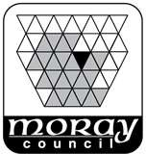
EDUCATION, COMMUNITIES & ORGANISATIONAL DEVELOPMENT
Mrs Janice Simpson
Head Teacher Lossiemouth High School Coulardbank Road Lossiemouth IV31 6JU Telephone: 01343 812047

Email: admin.lossiehigh@moray-edunet.gov.uk
www.moray.gov.uk
21 February 2023
Dear Parents and Carers

Calculators in SQA exams

In some SQA exam papers, pupils are allowed to take in their own calculators. While a scientific calculator is permitted, an algebraic calculator, or any other type of ‘smart’ calculator, is not. The SQA has stated in their guidance that:

Where calculators are allowed in an exam they must not have been designed or adapted to offer any of the following facilities:
- ​language translators
- symbolic algebra manipulation, symbolic differentiation, or integration
- have any retrievable information stored on them, eg databanks, dictionaries, mathematical formulas
- be able to access any other devices or the internet​

The invigilators and Mrs Petrie will inspect calculators on the way into any exams where they are permitted, but in order to avoid any unnecessary stress on the day of the exam, we would appreciate if your child could check with their teachers in advance whether the calculators they have meet the regulations.

The school can provide an alternative calculator for any pupils who do not have a suitable calculator, and there will be calculators readily available in the exam room the invigilators can give to pupils if necessary.

Please do not hesitate to contact the school if you would like to discuss this further.

Yours faithfully,

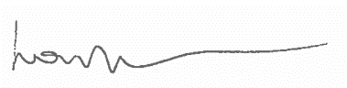

Mrs Louise Petrie,
Depute Head Teacher

Calculators are allowed in the following SQA Exams:

