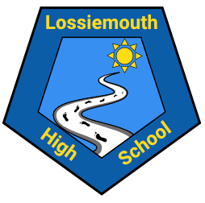
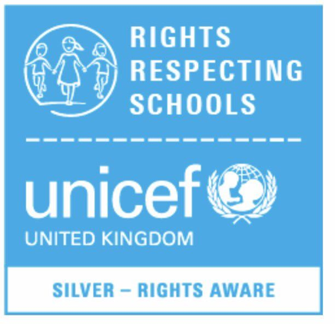
Welcome to the March 2022 edition of the LHS Rights Respecting School Newsletter! Despite the continuing disruption from the pandemic, we have been making excellent progress since we achieved our silver award in June 2021. We continue to work towards achieving our gold award.

Rights Respecting Schools at LHS
Whats been happening?
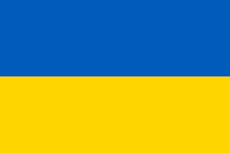
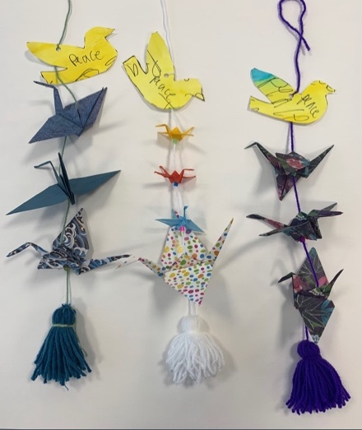

We recently sent out a whole-school survey to pupils, staff and parents to gauge when our school community thought we would be ready to seek Gold accreditation. Thank you to everyone in our community for their help in collecting invaluable feedback. After the survey results, the staff Rights Respecting Schools School Improvement group met to discuss all findings. It was agreed that we seek to obtain the gold award in June 2023.
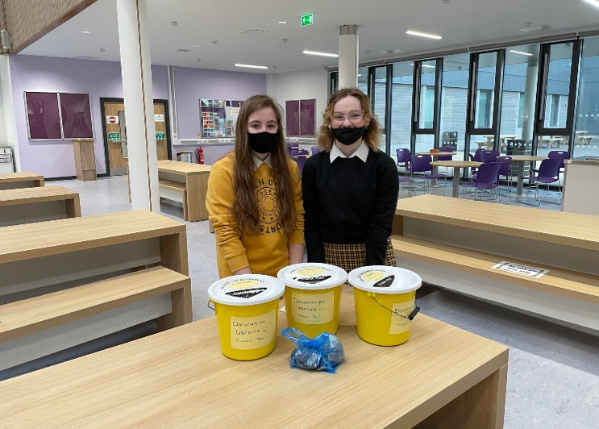
DES Ukraine Appeal
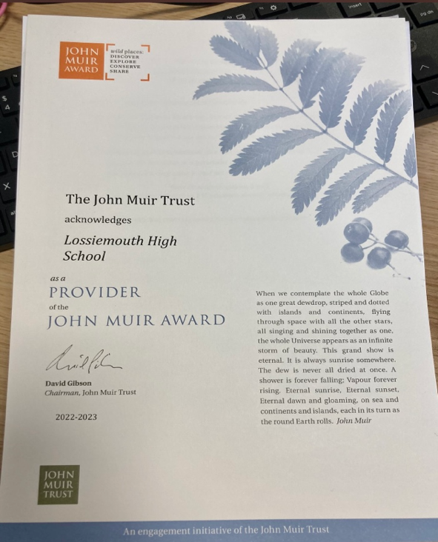
Lossiemouth High School S6 Fundraising Committee organised a ‘wear something blue or yellow day’ in order to raise funds for refugees in Ukraine. A wonderful total of £1000 was raised for this very important cause! Well done to our S6 Fundraising Committee for coordinating such a fantastic whole-school event in such a short amount of time.

The John Muir Award
All S2 pupils have been learning about Article 31 - the right to explore a safe environment while engaging in cultural activities.
S2 have enjoyed successful completion of the Discovery Award. This award has been undertaken by our S2 pupils and certificated by the John Muir trust.
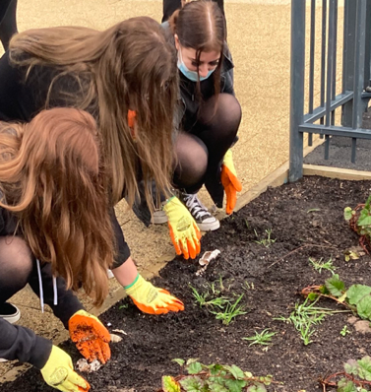
What is the John Muir Award?
The John Muir Award is an environmental award scheme focused on wild places. It supports people to connect with, enjoy and care for nature, landscape, and the natural environment. Our pupils have enjoyed a range of activities in their local school grounds to gain the award.
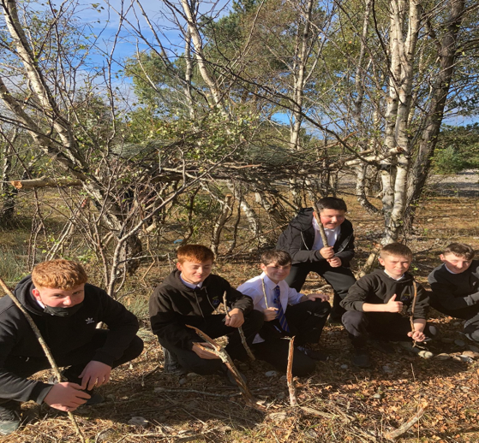
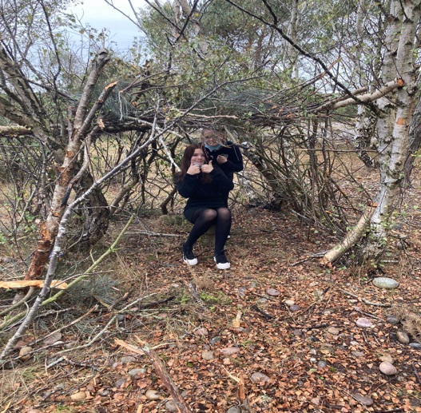

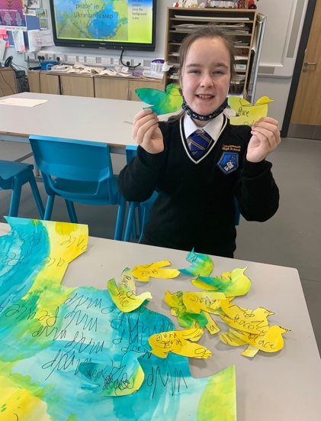
Global Peace Crane Project
Over the past academic year the Art and Geography department have been working with the whole school on a peace crane making mission! The school is sending 1000 peace cranes to Hiroshima to be desplayed at the Childrens Peace Memorial in Japan.
The Art department has also made many global connections exchanging peace cranes with pupils in countries such as Taiwan, Estonia and the USA!
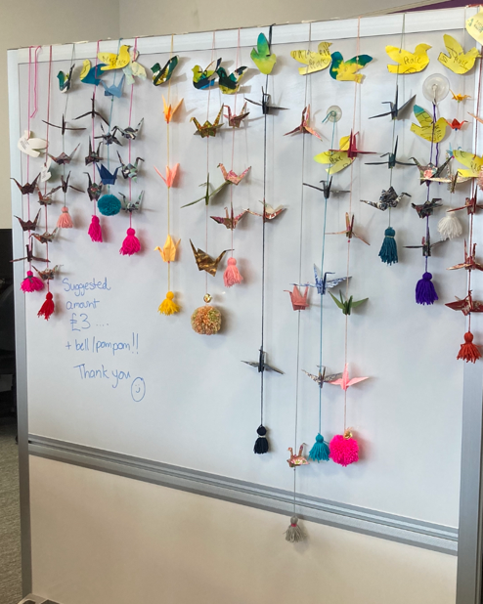
Pupils put together peace cranes strings to stand in solidarity with refugees in Ukraine. These will be on sale during rights week in June to raise additional funds in support of the DES Ukrane appeal.
RRS trip to Edinburgh and Letters to MSPs
We would like to send a special thank you to our Parent Partnership for helping us secure funding for our RRS steering group to take a trip to the Scottish Parlament. Both the BGE and Senior Phase steering group will be headed to Parlament on the 9th of June. On our trip, pupils will get the chance to speek with MSPs and attend First Ministers Question Time. This will be a wonderful opportunity for our pupils to engage with the Scottish Government. They have focused on mental health this academic year and worked in colaberation with Unicef’s Outright Campaign. To highlight issues with mental health in schools, both our steering groups have worked extremely hard to write letters to MSPs. Thus, ensuring they use their voice to empower effective change for young people in Scotland.
Follow us on Twitter

Interested in keeping up with our journey to gold?

Follow our Twitter page!
@LossiemouthRrs

