Lossiemouth High School
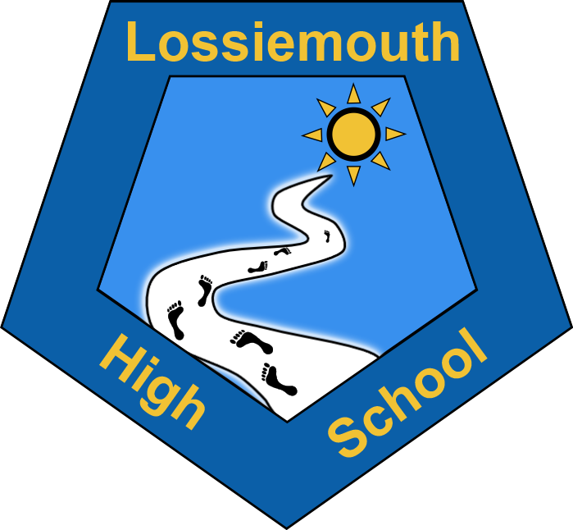

Vision
Lossiemouth High School is committed to striving for success, ensuring everyone feels included and valued and achieves their potential in a welcoming and safe environment.

Values
Respect
Effort
Resilience
Responsibility
Aims
To develop respectful, resilient, resourceful and aspirational young adults

…in a community to be proud of…

Mission
‘Working together to make ambitions a reality’

