NATIONAL QUALIFICATIONS CURRICULUM SUPPORT

Chemistry

Organic Spectroscopy

Structural Determination Workshop

[ADVANCED HIGHER]



The Scottish Qualifications Authority regularly reviews the arrangements for National Qualifications. Users of all NQ support materials, whether published by Education Scotland or others, are reminded that it is their responsibility to check that the support materials correspond to the requirements of the current arrangements.

Acknowledgement
The publisher gratefully acknowledges permission to use the spectra provided by Professor Marcel Jaspars, Department of Chemistry, University of Aberdeen.

© Crown copyright 2014. You may re-use this information (excluding logos) free of charge in any format or medium, under the terms of the Open Government Licence. To view this licence, visit http://www.nationalarchives.gov.uk/doc/open-government-licence/ or e-mail: psi@nationalarchives.gsi.gov.uk.
Where we have identified any third party copyright information you will need to obtain permission from the copyright holders concerned.

Any enquiries regarding this document/publication should be sent to us at enquiries@educationscotland.gov.uk.
This document is also available from our website at www.educationscotland.gov.uk.

Contents

Introduction 4

Spectra 5

Answers 17

Organic Spectroscopy – Structural Determination Workshop

Below are the structures of six organic compounds. The compounds have been analysed using mass spectrometry, IR spectroscopy and High Resolution ¹H NMR spectroscopy. The spectra for the compounds have been labelled A to F.
Do your best to match the structure of each of the compounds below to the spectra and gather the evidence to confirm you have correctly identified compounds A to F.
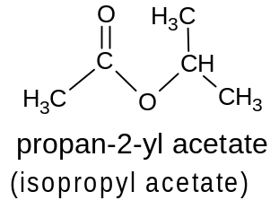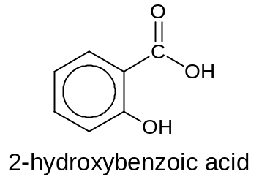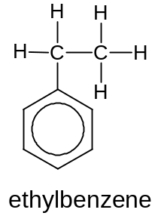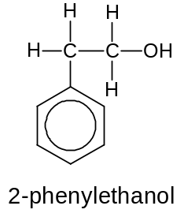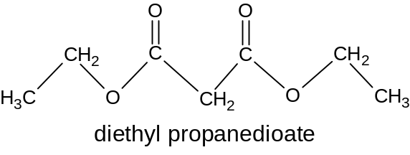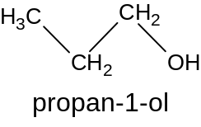
Compound A - ¹H NMR
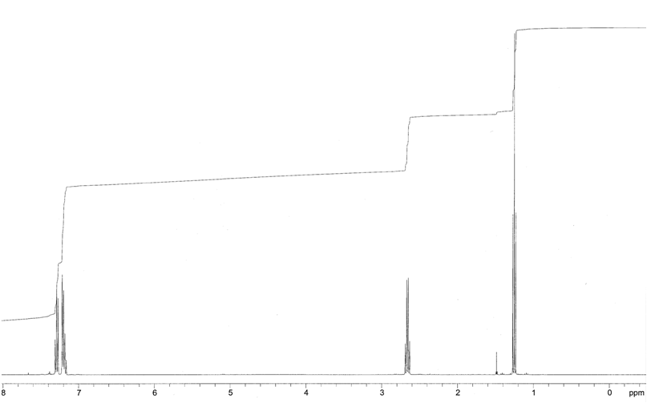
5H
3H
2H
5H

Compound A - Mass spectrum
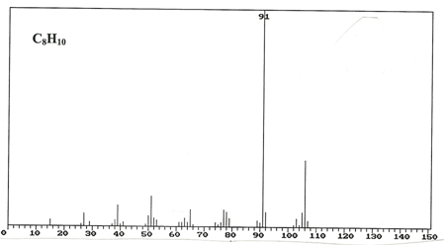

106

Compound A - IR spectrum
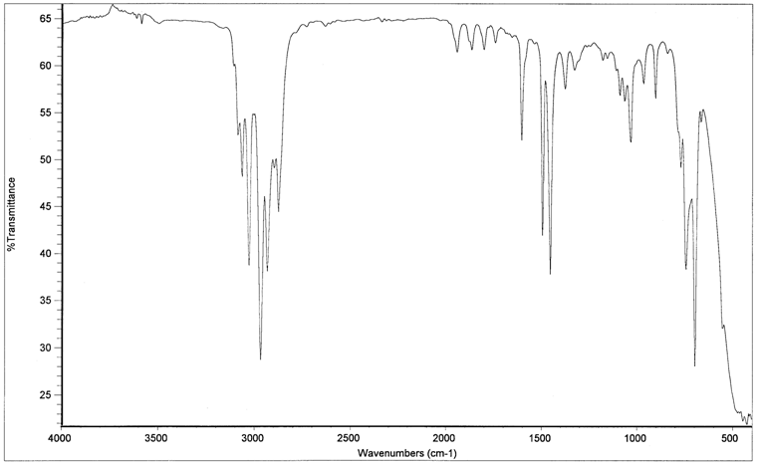

Compound B - ¹H NMR
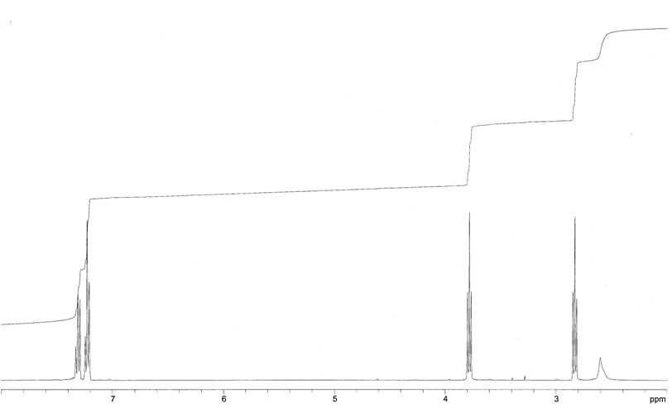
2H
2H

1H

5H

Compound B - Mass Spectrum

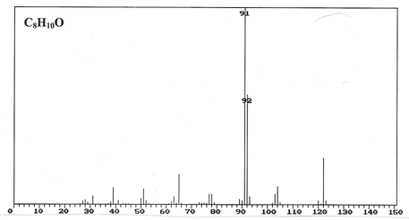
122

Compound B - IR Spectrum
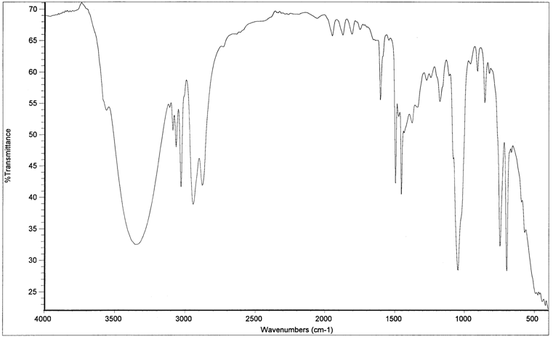

Compound C - ¹H NMR
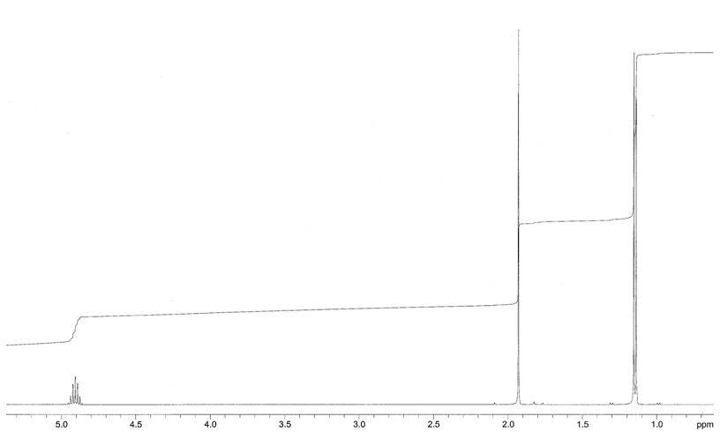
6H
3H
1H
Compound C – Mass Spectrum
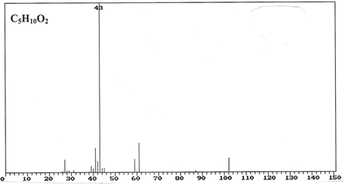
102

Compound C - IR Spectrum
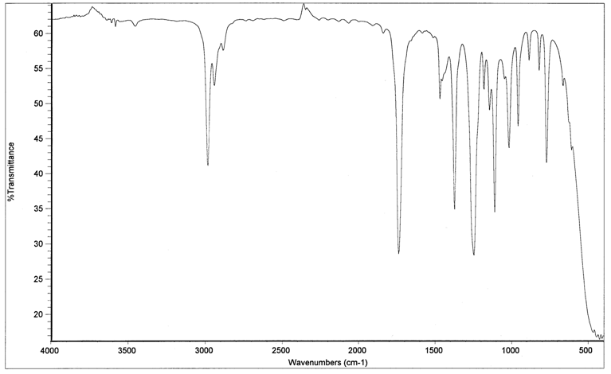

Compound D - ¹H NMR

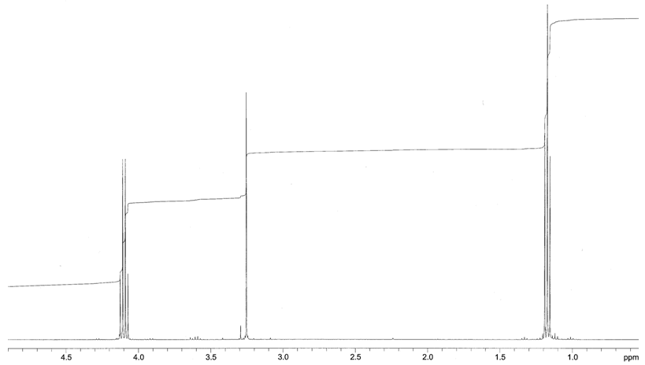
6H
2H
4H

Compound D – Mass Spectrum
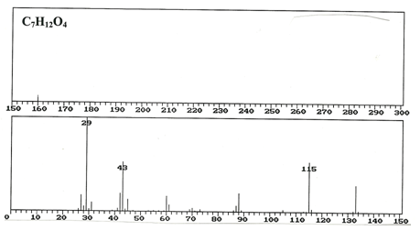
160

Compound D - IR Spectrum
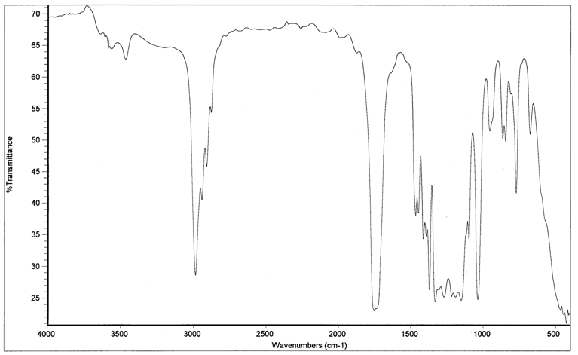

Compound E - ¹H NMR

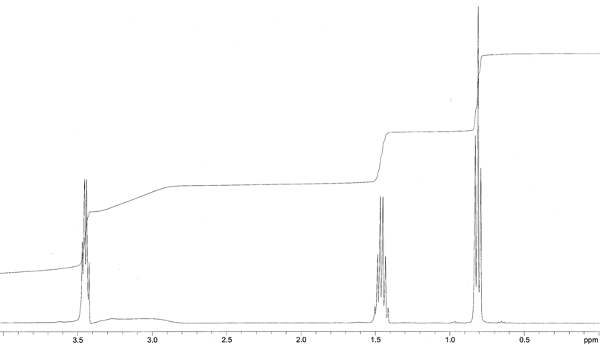
3H
3.2 ppm broad peak (1H)
2H
2H
Compound E – Mass Spectrum
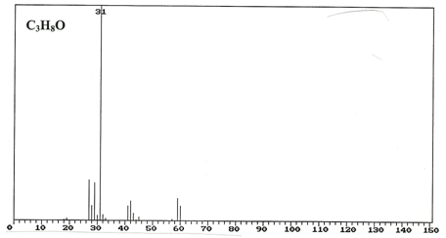
60

Compound E - IR Spectrum
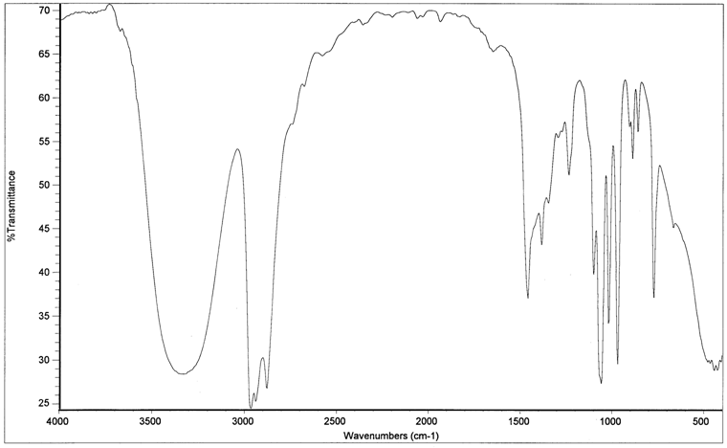

Compound F - ¹H NMR

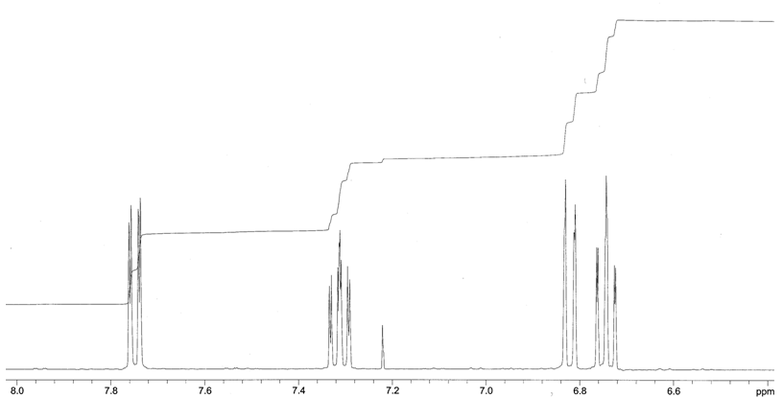
Note
A broad single peak integral = 2H was also observed at 10.5ppm

1H
1H
1H
1H
Compound F – Mass Spectrum
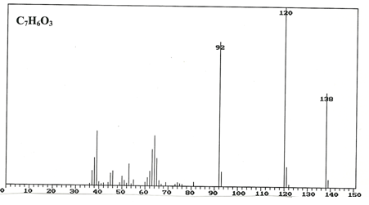

Compound F - IR Spectrum
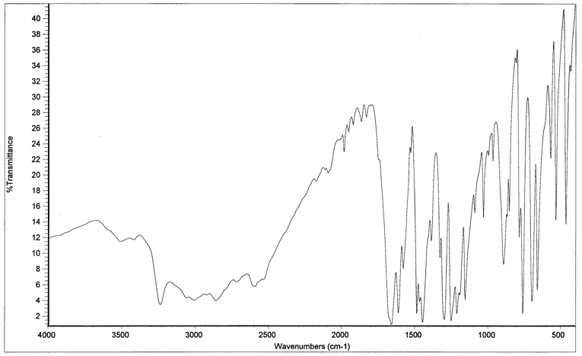

Answers
Compound A = ethylbenzene
Compound B = 2-phenylethanol
Compound C = propan-2-yl acetate (isopropyl acetate)
Compound D = diethyl propanedioate
Compound E = propan-1-ol
Compound F = 2-hydroxybenzoic acid

Compound A - ¹H NMR
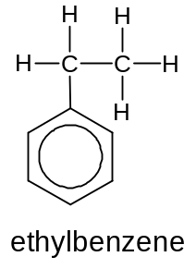
3H
CH₂CH₃
Triplet

2H

ArCH₂CH₃
Quartet

5H
ArH
5H

Compound A - Mass spectrum
Daughter ion
[C₆H₅CH₂]⁺
m/z = 91

Molecular ion [M]⁺
m/z = 106

Compound A - IR spectrum
Benzene ring

Benzene ring

benzene ring

Benzene ring

Alkane C-H

Compound B - ¹H NMR
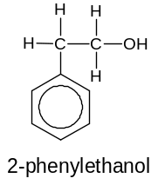
2H
CH₂CH₂-OH
triplet

1H
CH₂-OH

2H
CH₂CH₂
triplet
(next to a CH₂)

5H
ArH

Compound B - Mass Spectrum

Daughter ion
[C₆H₅CH₂]⁺ m/z = 91

Molecular ion [M]⁺
m/z = 122

Compound B - IR Spectrum
Benzene ring

Benzene ring

Broad –OH

Benzene ring
Benzene ring

Alkane C-H

Compound C - ¹H NMR
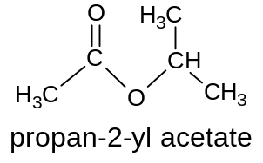
Symmetry means the CH₃ groups are in the same environment
6H
CH(CH₃)₂
Doublet

3H
CH₃COO
Singlet

1H
CH(CH₃)₂

Compound C – Mass Spectrum
Molecular ion
[M]⁺
m/z = 102

Daughter ion
[CH₃COO]⁺
m/z = 43

Compound C - IR Spectrum
Alkane C-H

Ester C=O

Compound D - ¹H NMR
2H
COCH₂CO
Singlet

Molecule is symmetrical so 3 environments for hydrogen

4H
CH₃CH₂O
Quartet
6H
CH₃CH₂O
Triplet

Compound D – Mass Spectrum
Daughter ion [CH₃CH₂OCOCH₂CO]⁺
m/z =115

Molecular ion [M]⁺
m/z = 160

Compound D - IR Spectrum
Alkene C-H

Ester C=O

Compound E - ¹H NMR

2H
CH₃CH₂CH₂OH

3H
CH₃CH₂CH₂OH

2H
CH₃CH₂CH₂OH
1H
3.2 ppm broad peak
-OH

C ompound E – Mass Spectrum
Daughter ion
[HOCH₂]⁺
m/z = 31

Molecular ion [M]⁺
m/z = 60

Compound E - IR Spectrum
Alkane C-H

Broad -OH

Compound F - ¹H NMR
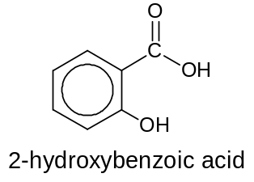
Note
A broad single peak integral = 2H was also observed at 10.5ppm
This is the -OH and COOH peaks overlapping.
1H
ArH

1H
ArH

1H
ArH

1H
ArH
Compound F – Mass Spectrum
Daughter ion [C₆H₄COO]⁺
m/z = 120

Daughter ion [C₆H₄O]⁺
m/z = 92

Molecular ion [M]⁺
m/z = 138

Compound F - IR Spectrum
Broad COOH
and -OH

Aromatic

