NAME and CLASS : __________________________

National 5
Chemical Changes and Structure

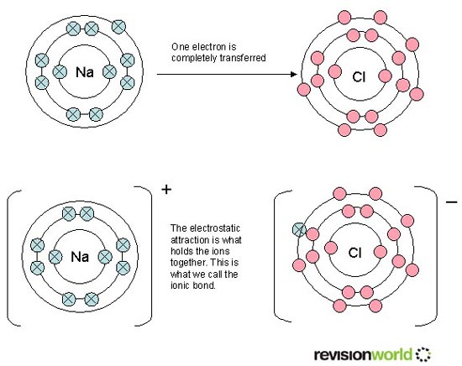

National 5 - In this Unit, learners will develop scientific skills and knowledge of the chemical reactions in our world. Through practical experience, learners will investigate average rates of reaction and the chemistry of neutralisation reactions. Focusing on these reactions, learners will work towards the concept of balanced chemical equations. Learners will explore the mole concept, formulae and reaction quantities. The connection between bonding and chemical properties of materials is investigated.

The following websites may be useful for this unit

The interactive student guide to all levels of chemistry in Scotland. On this site you will be able to access revision material, exercises and tests.  USER NAME = Lossiemouth PASSWORD = iron | http://www.evans2chemweb.co.uk
Information on Atomic structure | http://web.jjay.cuny.edu/~acarpi/NSC/3-atoms.htm
Jefferson’s lab – interactive games on atoms elements and compounds. | http://education.jlab.org/qa/atom_idx.html
Interactive periodic table | http://www.webelements.com/
Bonding structure and properties | http://www.footprints-science.co.uk/ionic.htm  http://ibchem.com/IB/ibnotes/full/bon_htm/4.2.htm
Acids and alkalis | http://www.bgfl.org/bgfl/custom/resources_ftp/client_ftp/ks3/science/acids/
Learning Intentions Chemical Changes and Structure National 5
By the end of this unit you should know the following

(a) Rates of reaction
Factors affecting rate
- The rates of reactions are affected by changes in concentration, particle size and temperature.
- The collision theory can be used to explain the effects of concentration and surface area on reaction rates.
- Catalysts are substances that speed up reactions but can be recovered chemically unchanged at the end of a reaction.
- Enzymes are biological catalysts

Following the course of a reaction
- Reactions can be followed by measuring changes in concentration, mass and volume of reactants and products.
- Construct graphs and add lines to it to show differences in the rate and the end-point of a reaction when conditions have been changed.
- The average rate of a reaction can be calculated from a graph of the change in mass or volume against time using initial and final quantities and the time interval.

(b) Atomic structure and bonding related to properties of materials
Elements
- When a substance contains only one kind of atom it is known as an element
- Elements are arranged in the periodic tale in order of increasing atomic number
- Elements with similar properties are grouped together
- Elements can be grouped together as metals and non metals

Compounds
- Most compounds with a name ending in ‘-ide’ contain the two elements indicated; the ending ‘-ite’ or ‘-ate’ indicates the additional element oxygen.
- Compounds are formed when elements react together.

Word equations
- A chemical reaction which can be described using word equations.

Chemical symbol equations
- A chemical reaction which can be described using chemical symbols,
- State symbols are used to show the state of species.

The structure of the atom Sub-atomic particles
- All matter is made up of very small particles called atoms.
- The atom has a nucleus, which contains protons and neutrons, with electrons moving around outside the nucleus.
- Protons have a charge of 1+ (positive), neutrons are neutral and electrons have a charge of 1-(negative).
- An atom is neutral because the numbers of protons and electrons are equal.
- Protons and neutrons have an approximate mass of one atomic mass unit and electrons, in comparison, have virtually no mass.

Important numbers
- Atoms of different elements have a different number of protons, called the atomic number.
- The electrons in an atom are arranged in energy levels.
- The elements of the Periodic Table are arranged in terms of their atomic number and chemical properties.
- Elements with the same number of outer electrons have similar chemical properties.
- An atom has a mass number which equals the number of protons plus neutrons.
- The number of protons, neutrons and electrons can be found from the atomic number and mass number, and vice versa.
- Atoms can be represented by nuclide notation, eg ₃₇
¹⁷ ^{Cl}
Isotopes
- Isotopes are atoms with the same atomic number but different mass numbers.
- Most elements exist as a mixture of isotopes.
- Relative atomic mass is the average mass of the isotopes present taking into account their relative proportions.
- The relative atomic mass of an element is rarely a whole number.

Ions
- When there is an imbalance in the number of positive protons and negative electrons the particle is known as an ion.

Bonding
- Atoms can be held together by bonds.
- In forming bonds, atoms can achieve a stable electron arrangement.
- There are two types of compound.

Ionic compounds
- Ionic compounds are usually formed when metals combine with non-metals.
- Positive ions are formed by metal atoms losing electrons and negative ions are formed by non-metal atoms gaining electrons.
- Ionic bonding is the attraction between oppositely charged ions.
- Ionic bonds are the electrostatic attraction between positive and negative ions.
- Ionic compounds form lattice structures of oppositely charged ions.
- An ionic structure consists of a giant lattice of oppositely charged ions.
- The formula for an ionic compound gives the simplest ratio of positive ions to negative ions.

Covalent Compounds
- Covalent compounds form when non-metal atoms bond together.
- In a covalent bond atoms share pairs of electrons.
- The covalent bond is a result of two positive nuclei being held together by their common attraction for the shared pair of electrons.
- Covalent bonds are strong forces of attraction.
- Covalent compounds exist as molecules
- A molecule is a group of atoms held together by covalent bonds.
- A diatomic molecule is made up of two atoms.
- Hydrogen, nitrogen, oxygen, the halogens and carbon monoxide exist as diatomic molecules.
- Covalent substances can form either discrete molecular or giant network structures.
- Diagrams can be drawn to show how the outer electrons are shared to form the covalent bond(s) in a molecule.
- Covalent substances can consist of discrete molecules.
- The formula for a discrete covalent substance gives the actual number of atoms in each molecule.
- Formulae can be written from models or given molecular pictures.
- A covalent network structure consists of a giant lattice of covalently bonded atoms.
- The formula for a covalent network substance gives the simplest ratio of atoms of each element.

Formulae
- Formulae can be written for names using prefixes, including mono-, di-, tri-, tetra-.
- Formulae for two-element compounds are written using valency rules.
- A chemical reaction which can be described using word equations,
- The ratio in which elements combine to form two element compounds can be determined using valency rules.
- The chemical formula can also be determined from names with prefixes, models or structures.
- Chemical and, ionic formulae including compounds containing group ions are used.
- Formulae can be written for compounds involving group ions but not requiring brackets, eg Na₂SO₄.
- Formulae can be written for compounds using Roman Numerals, eg for iron(III) chloride.
- Formulae can be written for compounds requiring brackets, eg Mg(OH)₂.

Properties
- To be sure of the bonding present in a substance the properties must be tested
- Covalent substances (solids, liquids, solutions) do not conduct electricity since they are made up of molecules which are uncharged.
- Ionic compounds do not conduct electricity in the solid state but these compounds do conduct electricity when dissolved in water or when molten..
- Discrete covalent substances have low melting and boiling points.
- Covalent compounds, made of molecules, have low melting and boiling points. As a result, they can be found in any state at room temperature.
- The bonds between covalent molecules are weaker than the covalent bonds within molecules.
- Covalent molecular substances have low melting and boiling points due to only weak forces of attraction between molecules being broken.
- Giant covalent network structures have very high melting and boiling points because the network of strong covalent bonds must be broken.
- Ionic compounds have high melting and boiling points. As a result, they are found in the solid state at room temperature.
- Many ionic compounds are soluble in water. As they dissolve the lattice structure breaks up allowing water molecules to surround the separated ions.
- Covalent substances which are insoluble in water may dissolve in other solvents.
- Ionic compounds have high melting and boiling points because strong ionic bonds must be broken in order to break down the lattice.
- Dissolving also breaks down the lattice structure.
- Ionic compounds conduct electricity, only when molten or in solution due to the breakdown of the lattice resulting in the ions being free to move.
- Conduction of ionic compounds can be explained by the movement of ions towards oppositely charged electrodes
- Experimental procedures are required to confirm the type of bonding present in a substance.
.
- An electric current is a flow of charged particles.
- Electrolysis is the flow of ions through solutions and molten compounds (electrolytes).
- Electrolysis chemically changes the electrolyte and may lead to the break up of the compound.
- Positive metal ions gain electrons at the negative electrode and negative non-metal ions lose electrons at the positive electrode.

(c) Acids and alkalis (bases)

The pH scale
- The pH scale is a continuous range from below 0 to above 14.
- Acids have a pH of less than 7; alkalis have a pH of more than 7; pure water and neutral solutions have a pH equal to 7.
- Non-metal oxides which dissolve in water produce acid solutions.
- Metal oxides and hydroxides which dissolve in water produce alkaline solutions.
- Ammonia dissolves in water to produce an alkali.
- In water and neutral solutions, the concentration of hydrogen ions is equal to the concentration of hydroxide ions.
- An acidic solution contains more hydrogen ions than hydroxide ions.
- An alkaline solution contains more hydroxide ions than hydrogen ions.
- The effect of dilution on the pH of an acid or alkali is explained in terms of the decreasing concentration of hydrogen and hydroxide ions.
- In water and aqueous solutions there is an equilibrium between hydrogen and hydroxide ions and water molecules.

Reactions of acids
- Neutralisation is the reaction of acids with bases.
- A salt is also formed in this reaction.
- Salts are formed in the reaction of acids with bases or metals.
- Hydrochloric acid forms chloride salts, sulphuric acid forms sulphate salts and nitric acid form nitrate salts.
- Metal oxides, metal hydroxides and metal carbonates are examples of bases.
- Bases which dissolve in water form alkalis.
- Neutralisation moves the pH of an acid up towards 7.
- Neutralisation moves the pH of an alkali down towards 7.

Ionic equations
- For the neutralisation reactions of acids with alkalis or metal carbonates, the reacting species is determined by omission of spectator ions.
- Spectator ions can be identified in neutralisation and precipitation reactions and the equations can be rewritten omitting these ions.
- A salt is a compound in which the hydrogen ions of an acid have been replaced by metal ions (or ammonium ions).
- Acid + Alkali → Salt + Water
- Name the salt produced from the name of the acid and alkali
- In the reaction of an acid with an alkali the hydrogen ions and hydroxide ions form water.
- Acid + Reactive → Metal Salt + Hydrogen
- Name the salt produced from the name of the acid and reactive metal
- An acid reacts with some metals to give off hydrogen gas.
- The test for hydrogen is that it burns with a pop.
- In the reaction, hydrogen ions form hydrogen molecules.
- Acid + Metal oxide → Salt + Water
- Name the salt produced from the name of the acid and the metal oxide
- In the reaction of an acid with a metal oxide the hydrogen ions and the oxide ions form water.
- Acid + Metal carbonate → Salt + Water + Carbon dioxide
- Name the salt produced from the name of the acid and the metal oxide
- In the reaction of an acid with a metal carbonate the hydrogen ions and carbonate ions form water and carbon dioxide.

- The course of a neutralisation reaction can be followed using a pH indicator; if the base is insoluble an indicator is not required.
Acid Rain
- Sulphur dioxide, produced by the burning of fossil fuels, and nitrogen dioxide, produced by the sparking of air in car engines, dissolve in water in the atmosphere to produce acid rain.
- Acid rain has damaging effects on buildings made from carbonate rock, structures made of iron and steel, soils and plant and animal life.
- Lightning storms supply much needed nitrates to the soil of rain forests.

Volumetric titrations

Titration is an analytical technique used to determine the accurate volumes involved in chemical reactions such as neutralisation.

An indicator is used to show the end-point of the reaction.
- The concentration of acids/alkalis can be calculated from the results of volumetric titrations.

Neutralisation reactions can be used to prepare soluble salts
- Titration can be used to produce a soluble salt. Once the volumes of acid and alkali have been noted, the reaction can be repeated without the indicator to produce an uncontaminated salt solution. The solution can then be evaporated to dryness.
- Insoluble metal carbonates and insoluble metal oxides can be used to produce soluble salts. Excess base is added to the appropriate acid, the mixture is filtered and the filtrate evaporated to dryness

(d) Formulae and reaction quantities
Number of moles

- From the formula of a substance, its formula mass can be calculated using the Relative Formula Mass of the elements.
- The formula mass of any substance expressed in grams is known as one mole.
- The number of moles can be calculated from the mass of a substance and vice versa.

Concentration
- The concentration of solutions is expressed in moles per litre (mol l⁻¹).

- The number of moles of solute, volume and concentration of solution can be calculated from the other two variables.
Balanced equations
- Formulae equations can be balanced to show the relative number of moles of reactant(s) and product(s).
- The mass of a reactant or product can be calculated using a balanced equation.

a) Rates of reactions

Level | Learning intentions | Traffic light
Nat 4 | I can monitor the rate of reaction and interpret graphs relating to the rate of reaction.
Nat 4 | I can add lines to a graph to show the effect of changing the reaction conditions
Nat 4 | I can use collision theory to explain the effects of concentration, temperature and surface area on reaction rates
Nat 5 | I can calculate the average rate of reaction from a graph the change in mass, concentration or volume against time using initial and final quantities and the time interval.

Prior knowledge (from your previous studies you should know)

Collision theory
Collision theory says that particles must collide before a reaction can occur. Any factor that increases the number of collisions will increase the speed of a reaction. We can change the conditions to make a reaction faster or slower.

- List three factors that can change the rate (speed) of a reaction

- What is a catalyst?

- What is an enzyme?

Experiment 1 – Effect of surface area on the reaction of acid and magnesium

Magnesium reacts with hydrochloric acid.

Magnesium (s) + Hydrochloric acid (aq) → Magnesium chloride (aq) +Hydrogen (g)
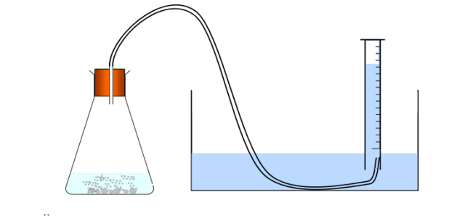

. Measuring the volume of gas over water

The experiment was repeated using magnesium ribbon and magnesium powder

- List the variables that must be kept to make the experiment fair

- Plot the results on a graph. Use the same set of axes for both sets of results.

time (s) | 0 | 30 | 60 | 90 | 120 | 150 | 180 | 210
volume of gas(cm³)
RIBBON
Volume of gas (cm³)
POWDER

The …………… the reaction the steeper the graph.

The graphs level off at the ……… of the reaction.

Both graphs level off at the ……… height as equal quantities of reactants produced an ………. volume of gas in each experiment.

Conclusion

- Use collision theory to explain your conclusion

Experiment 2 - Effect of concentration on the rate of reaction between acid and marble chips.

Let us consider marble chips and excess acid added together and the mass of the flask taken every 20secs

Calcium carbonate (s) + Hydrochloric acid (aq) → Calcium chloride (aq) + water (l) + Carbon dioxide (g)
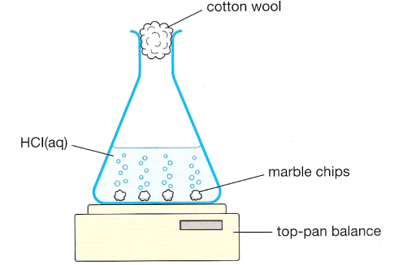
A gas is produced.
As the gas escapes from the beaker, the mass …………

The experiment was repeated changing the concentration of the acid.

- List the variables that must be kept constant to make the experiment fair

- Plot the results on a graph. Use the same set of axes for both sets of results.

time (s) | 0 | 20 | 40 | 60 | 80 | 100 | 120 | 140
Mass of flask (g)
(1 moll⁻¹ acid)
Mass of Flask (g)
(2 moll⁻¹ acid)

The …………… the reaction the steeper the graph.

The graphs level off at the ……… of the reaction.

Both graphs level off at the ……… height as equal quantities of reactants produced an ………. mass of gas in each experiment.

Conclusion

- Use collision theory to explain your conclusion

Experiment 3 - Effect of temperature on the rate of reaction between magnesium and acid.

Let us consider magnesium ribbon and excess acid added together

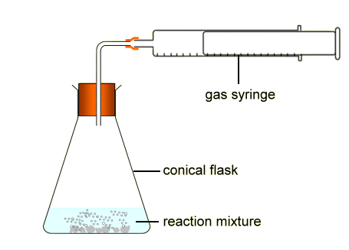
Magnesium (s) + Hydrochloric acid (aq) → Magnesium chloride (aq) + Hydrogen (g)

A gas is produced.

As the gas escapes from the beaker, the mass …………

The experiment was repeated changing the ………… of the acid.

Plot the results on a graph. Use the same set of axes for both sets of results.

time (s) | 0 | 10 | 20 | 30 | 40 | 50 | 60 | 80
Volume of gas (cm³)
25ºC
Volume of gas (cm³)
30ºC

The …………… the reaction the steeper the graph.

The graphs level off at the ……… of the reaction.

Both graphs level off at the ……… height as equal quantities of reactants produced an ………. mass of gas in each experiment.

Conclusion

- Use collision theory to explain your conclusion

Effect of a catalyst or enzyme

Catalysts are substances that speed up chemical reactions but can be recovered chemically unchanged at the end of the reaction.

Catalysts function by providing a different path for the reaction.

e.g. Iron is used as a catalyst in the production of ammonia in the Haber process.
Platinum is used as a catalyst to oxidise ammonia to nitrogen dioxide in the Ostwald process.

Hydrogen peroxide breaks down or decomposes into water and oxygen.

2H₂O₂ (aq) → 2H₂O (l) + O₂ (g)

At room temperature this reaction is very slow.

When a catalyst is added to hydrogen peroxide the rate of decomposition is increased.

Enzymes are biological catalysts.

Interpreting graphs

The results of speed of reaction experiments are often presented on a graph.

5g of zinc was added to excess acid and the volume of gas measured.

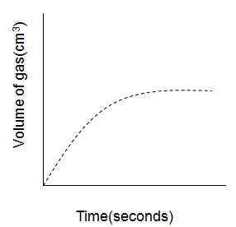
The steeper the line the faster the reaction.

- Where on the graph is the reaction fastest?

- What is happening to the rate of reaction as the reaction proceeds?

- Why does the graph level off?

The flat section of the graph (plateau) represents the final volume/mass or end of the reaction.
Increasing the mass, volume or concentration of a reactant will increase the height of the graph accordingly.
- Add a line to the graph above to show what would happen if 10g of zinc was added to excess acid.

The graph below summarises the differences in the rate of reaction at different temperatures, concentrations and size of pieces. The steeper the line, the greater the rate of reaction.
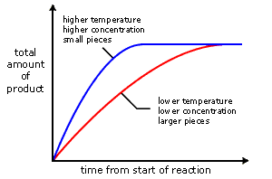
Concentration
of
product

Lower temperature
Lower concentration
Smaller surface area

Higher temperature
Higher concentration
Larger surface area

You may be asked to sketch on to a graph the effect of changing a variable (temperature, particle size or concentration) or changing the quantities of reactant.
Calculating the average rate of reaction

The average rate or speed of chemical reaction can be defined in terms of the change in some property of a substance involved in the reaction divided by the time it takes for this change to take place.

If the property monitored is concentration – either of a reactant or of a product – the average rate of the chemical reaction can be expressed as:

average rate = Δ quantity
Δ time

The following graph shows how the volume of gas changed during a reaction.

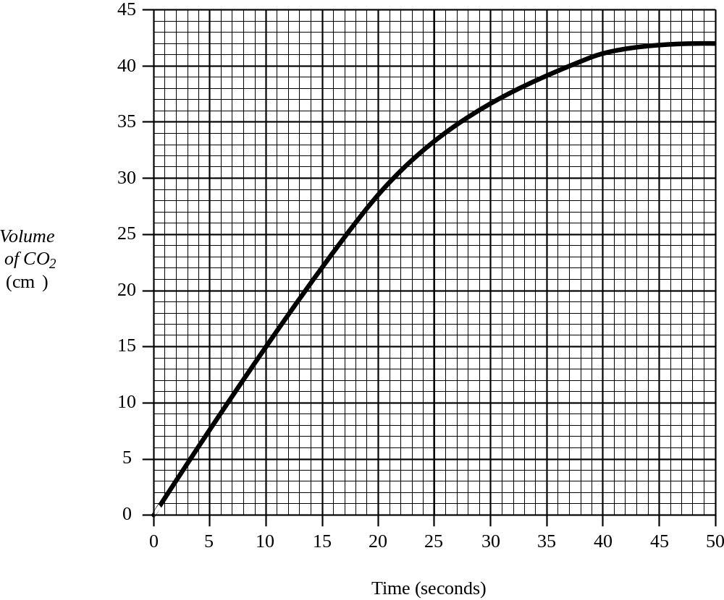

The average rate of the reaction over the first 20 s can be calculated as follows.

Average rate = Δ volume
Δ time

= 28.5 – 0 (from graph)
20-0

= 28.5
20

= 1.43 cm³ s⁻¹
- Using the graph, calculate the average rate of reaction,
- 20 – 30s

- 30 – 40s

- 40-50s

- What happens to the reaction rate as the reaction proceeds?

b) Atomic structure and bonding related to properties of materials

Level | Learning intentions | Traffic light
Nat 4 | I can describe the difference between an element and a compound and have carried out simple reactions to form two-element compounds.
Nat 4 | I can name compounds from the elements present and identify the elements present in a compound.
Nat 4 | I can use word equations, state symbols and chemical symbol equations to describe chemical reactions.
Nat 4 | I know elements are arranged in the periodic table in order of increasing atomic number and elements with similar chemical properties are grouped together.
Nat 4 | I can describe the basic structure of the atom in terms of protons, neutrons and electrons giving the, charge, mass and location of these particles.
Nat 4 | I can calculate the number of protons neutrons and electrons in an atom from the atomic number and mass number.
Nat 4 | I can explain why an atom is overall neutral.
Nat 5 | I can use nucleotide notation, eg. 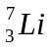.
Nat 5 | I can state what isotopes are and explain why relative atomic mass of an element is rarely a whole number
Nat 5 | I know how ions are produced.
Nat 4 | I can draw diagrams to show the electron arrangement of an atom.
Nat 4 | I know that covalent compounds are formed when non-metal atoms form covalent bonds by sharing their outer electrons.
Nat 5 | I can explain that covalent substances can exist as discrete molecules or covalent networks and explain the significance of the chemical formulae for each.
Nat 5 | I can draw diagrams to show how the outer electrons are shared to form covalent bonds in a molecule.
Nat 5 | I can explain what a diatomic molecule is and give examples
Nat 5 | I can give examples of covalent network compounds.
Nat 4 | I know that ionic compounds are formed from metal and non-metal atoms by transferring electrons.
Nat 5 | I can state that ionic bonds are the electrostatic attraction between oppositely charged ions.
Nat 5 | I know an ionic structure consists of a giant lattice structure and that the formula for an ionic compound represents the simplest ratio of the atoms present.
Nat 4 | I can describe the properties of covalent and ionic compounds, state at room temperature, melting point and electrical conductivity.
Nat 4 | I can determine the formula for a compound from the valency rules.
Nat 4 | I understand to be sure of the type of bonding present in a substance the properties must be tested.
Nat 4 | I can write chemical formulae from the name of a compound using prefixes mono- di- tri- etc.
Nat 5 | I can write chemical formula using the valency rules.
Nat 5 | I can write ionic formulae.
Nat 5 | I can write chemical and ionic formulae for compounds involving group ions, brackets and or roman numerals.
Nat 4 | I can calculate the formula mass of a compound using the relative atomic mass of the elements and state the correct units (a.m.u).
Nat 5 | I can state that one mole of a substance is defined as the relative formula mass expressed in grams
Nat 5 | I an use the formula 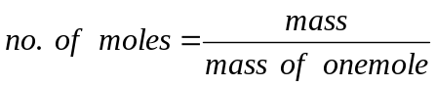  to solve simple problems
Nat 5 | I can write balanced formulae equations
Nat 5 | I can calculate the mass of a reactant or product using a balanced equation.
Nat 5 | I can describe the properties of covalent molecular, covalent network and ionic compounds, state at room temperature, melting point, electrical conductivity and solubility.
Nat 5 | I have investigated the properties of compounds and can relate the properties to the type of bonding and structure present.

Prior knowledge (from your previous studies you should know)

- Write a definition for

i) atom

ii) element

iii) compound

iii) molecule
Elements
Everything in the world is made from about 100 elements.

There is a different symbol for every element e.g. C for carbon, H for Hydrogen.

The first letter of the symbol is always a capital letter and the second letter (if there is one is a lower case letter).

The symbol for some elements is based on the Latin name, e.g. the symbol for potassium (kalium) is ……… and the symbol for …………………… (natrium) is Na.

Element | symbol
Rutherfordium
Indium
Rhenium
Radon
Polonium
Elements are arranged into the ……………….. ……………….
Each element is also given a unique number called the ………………… …………….. Elements are arranged in order of their atomic number in the Periodic Table.
Compounds

- Compounds are formed when elements react together.
- To separate the compounds into elements requires a chemical reaction.
- Compounds tend not to look or act like the elements from which they are made.

When different elements react together, they form a new compound.
+

Elements
Compound
Compounds contain two or more different types of atoms chemically joined together.

Naming compounds

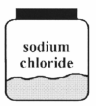
Rules for naming compounds:
1. The names of the elements are written in from left to right as they appear
in the Periodic Table. So metals come before non-metals.

2. The ending is changed to show that the elements have joined together.

3. Compounds ending 'ide' usually contain 2 elements joined together.

4. Compounds ending 'ate' or 'ite' usually contain 3 elements joined together
one of which is oxygen.

Elements present | Name of compound
 | magnesium oxide
 | silver chloride
lead + sulphur
oxygen + iron
 | copper carbonate
 | zinc sulphate
iron + sulphur + oxygen
calcium + carbon + oxygen
 | sodium nitrate

formula | name of compound |  | particle diagram | formula
KI |  |  |  | CH₄
NaNO₃ |  |  |  | CH₄
NiO
MgCl₂
CuSO₄
CaF₂
Word equations
A chemical reaction which can be described using word equations.

When chemicals react together at least one new substance is produced.
We use an arrow → to show that a reaction has taken place.

REACTANTS → PRODUCTS

The atoms present at the start of the reaction will be the same as at the end of the reaction but they will be bonded together differently.

We use different types of equation to represent chemical reactions.

Word equations give the names of the reactants and the products.
magnesium + oxygen → magnesium oxide

- Write word equations for the following reactions
- When sodium metal reacts with iron(II) chloride solution, iron metal and sodium chloride are formed

- When fluorine gas comes in to contact with calcium metal at high temperatures, calcium fluoride is formed in a very exothermic reaction.

Chemical symbol equations

A chemical reaction can be described using chemical symbols,

Chemical equations give the formulae of the reactants and the products.
Mg (s) + O₂ (g) → MgO (s)

State symbols are used to show the state of species.

State symbol | Meaning
(s) | Solid
(l) | Liquid
(g) | Gas
(aq) | Dissolved in water

Groups

A column of elements in the periodic table is called a group.

A row of elements in the periodic table is called a period.
Elements in the same group of the Periodic table have similar chemical properties.
Group 1 elements – the alkali metals all react violently with ......................................
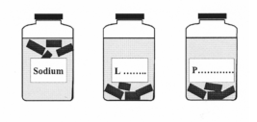

Elements in the same group have similar chemical properties.

Important groups include

Group | Name | Reactivity
I | Alkali Metals | Very reactive
2 | Alkaline Earth Metals | Reactive
7 | Halogens | Reactive non-metals
0 | Noble Gases | Very unreactive

The transition metals are an important block of elements between groups 2 and 3

- Complete the periodic table handout to show and classify

Which elements are metals/non metals
The Groups – alkali metals, halogens and the Nobel gases

The structure of the atom
Everything is made of very small particles called atoms.
Atoms contain even smaller particles: protons, neutrons and electrons.

The relatively heavy protons and neutrons are found clustered together in the centre of the atom, in the nucleus.

The fairly light electrons move around outside the nucleus.

- Complete the diagram of the atom and table below.

Particle | Charge | Approximate mass (a.m.u.) | Position in the atom
Proton | 1⁺
Neutron |  | 1
 | 1⁻ |  | Outside nucleus

Atoms are neutral because they contain .....................numbers of positive protons and negative ....................

Atomic number and Mass number

Elements are arranged in the Periodic table in order of their .................................

ATOMIC NUMBER = No. OF PROTONS
MASS NUMBER = No. OF PROTONS + No. OF NEUTRONS
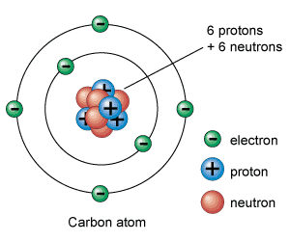
atomic number = 6
atomic number = number of protons
So number of protons = 6

mass number = 12
mass number = number of protons + no neutrons
so 12 = 6 + number of neutrons
number of neutrons = 12-6 = 6

Atoms are neutral because the number of protons = the number of electrons.
So this atom has 6 electrons.

atom | atomic number | mass number | No. protons | No. neutrons | No. electrons
H | 1 | 1 | 1
He | 2 | 4
 | 6 | 12
 |  | 24 | 12
 |  | 37 |  |  | 17

Nucleotide Notation and Isotopes
Chemists use nucleotide notation to show the number of subatomic particles in an atom or ion

The atomic number and the mass number are often written together with the symbol.

e.g. Mass number 24_{Mg}
Atomic number 12

The atomic number and the mass numbers can be found in the data book.

atom | atomic number | mass number | No. protons | No. neutrons | No. electrons
 |  | 1 | 1
H |  | 2
 | 1 | 3
Li |  |  |  | 3
 |  |  | 3 | 4
Cl |  | 35
 |  |  |  | 20 | 17
C |  |  | 6 | 6
C |  | 13
Ag |  | 107
Ag |  | 109

Isotopes are atoms of the same element with the same atomic number but different mass numbers.
Isotopes have the same number of .......................and .................... but a different number of ...................

Circle the sets of isotopes are in the table above.
Relative atomic mass
The relative atomic mass (RAM) of an element is the average mass of all the isotopes of a single element and is given in the data booklet. Relative atomic mass takes account of all the isotopes present and their abundance.

Two isotopes of chlorine exist
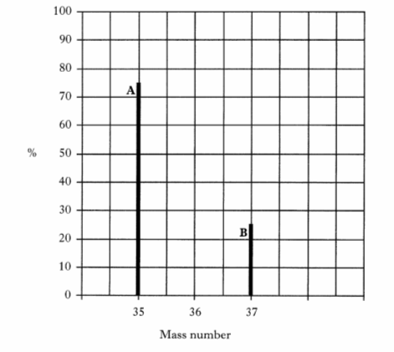
The relative atomic mass of an element can be calculated using the formula:

(mass of isotope A x %) + (mass of isotope B x %)
100

RAM of chlorine = (35 x 75) + (37 x 25)
100
= 35.5 a.m.u.

Example 1
Lithium has two isotopes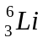 and
The RAM of Li is 6.9
Which is the more abundant isotope?

Example 2
Bromine has two isotopes 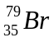 and 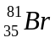
The RAM of bromine is 80.0
What does this suggest about the abundance of each isotope in a sample of bromine?

Ions

When there is an imbalance in the number of positive protons and negative electrons the particle is known as an ion. Metals form positive ions and non-metals form negative ions.

 | Mass number | Atomic no | Protons | Neutrons | Electrons
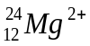
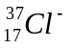
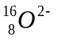
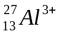
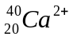
Electron arrangement
The electrons around the nucleus are arranged into energy levels.

High energy electrons are further from the nucleus.

Sodium has an electron arrangement 2, 8, 1

This means that there are
2 electrons in the first energy level
8 electrons in the second energy level and
1 electron in the third energy level

Draw a similar diagram and write the electron arrangement for each of the following:

lithium | calcium
magnesium | sulphur
chlorine | oxygen

Elements in the same .......................or column of the Periodic Table have the same number of ...................electrons.

Since it is the electrons which are involved in chemical reactions this means that elements in the same group or column of the Periodic Table have similar properties.

The Noble Gases
Atoms of the noble gases have a full outer energy level and this makes these elements stable and unreactive.
Helium | Neon | Argon | Krypton | Xeon
A full outer energy level is known as a stable electron arrangement.
Other atoms join together to achieve a stable electron arrangement.

Ionic bonding

Ionic compounds are formed from metals and non-metals.

Ionic bonding takes place when a metal atom losses electrons to complete its outer shell and a non-metal gains electrons to complete its outer shell.

A positive and a negative ion results and the electrostatic attraction between these ions is called an ionic bond.

Na
Cl
Na
XX
XX
X
X
X

o
Cl
XX
XX
X
X
X

o
+
→
2,8,1 2,8,7 2,8 2,8,8
sodium atom chlorine atom sodium ion chlorine ion
+
-

When a metal element reacts with a non-metal element a transfer of electrons takes place from the metal atoms to the non-metal atom so that both atoms can achieve a stable electron arrangement.

Forming Ions

Metal atoms lose electrons from the outer shell to reach the stable electron arrangement of the ‘nearest’ Nobel gas. Since electrons have a negative charge, the loss of electrons gives the metal ions a positive charge.

Non metal atoms gain electrons in the outer energy level to reach the stable arrangement of the ‘nearest’ Nobel gas. Since electrons have a negative charge, the gain of electrons gives non-metal ions a negative charge.

The table below shows the charges of the ions of the main group elements.

 | Group 1 | Group 2 | Group 3 | Group 4 | Group 5 | Group 6 | Group 7
Number of outer electrons | 1 | 2 | 3 | 4 | 3 | 2 | 1
Charge of ions | 1+ | 2+ | 3+ |  | 3- | 2- | 1-

In an ionic compound the charge of all the positive ions must balance the charge of all the negative ions.

Since the overall charge is neutral, the formula for an ionic compound can be worked.
Compound Potassium oxide
Positive Negative
Ions K⁺ O²⁻

Formula (K⁺)₂O²⁻
Compound Sodium chloride
Positive Negative
Ions Na⁺ Cl⁻

Formula Na⁺Cl⁻

Compound Magnesium chloride
Positive Negative
Ions Mg²⁺ Cl⁻

Formula Mg²⁺(Cl⁻)₂
Compound Lithium nitride
Positive Negative
Ions Li⁺ N³⁻

Formula (Li⁺)₃N³⁻

Note: If charges are included in the formula, the symbol and charge must be put in brackets when the balancing number is more than 1.

Crystal lattices

When a solid ionic compound is formed, the ions present, arrange themselves into a very regular structure called a CRYSTAL LATTICE. Each individual ionic substance forms its own type of crystal lattice.
The chemical formula for an ionic compound gives the ration of the ions in the crystal lattice

e.g. Sodium chloride
Na⁺Cl⁻
1 : 1
This means for every sodium ion there is one chloride ion in the crystal lattice.
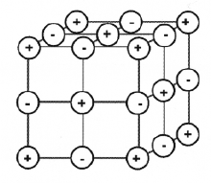
Sodium chloride lattice
+ sodium ions
- chloride ions

Covalent Bonding
Molecules are only formed when atoms of non-metals elements join together.
Molecules are made from non-metal elements joined by covalent bonds.
When non-metal elements join together, they share pairs of electrons to achieve a stable electron arrangement and the bond is called a covalent bond
We can draw diagrams to show how the outer elerctrons are shared to form covalent compounds
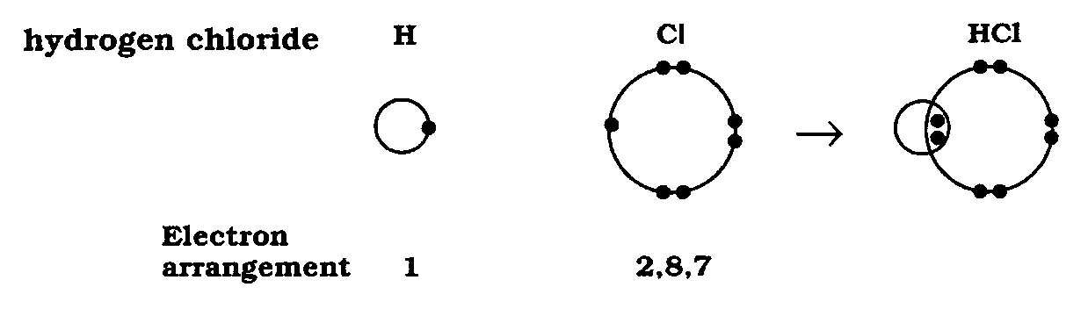

In the molecule hydrogen has 2 electrons and the outer energy level is now filled.
In the molecule chlorine has 8 electrons and the outer energy level is filled.
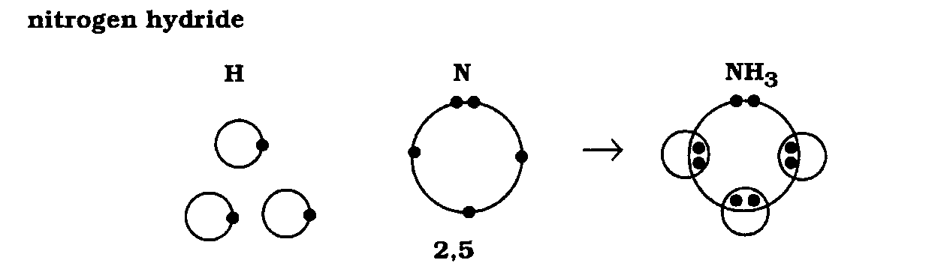

What is a covalent bond?
When two atoms share electrons, each nucleus tries to attract the shared electrons towards itself. (Remember that the nucleus is positive in charge, and the electrons are negative in charge).
The attraction of the two nuclei for the same shared pair of electrons holds the two atoms together.

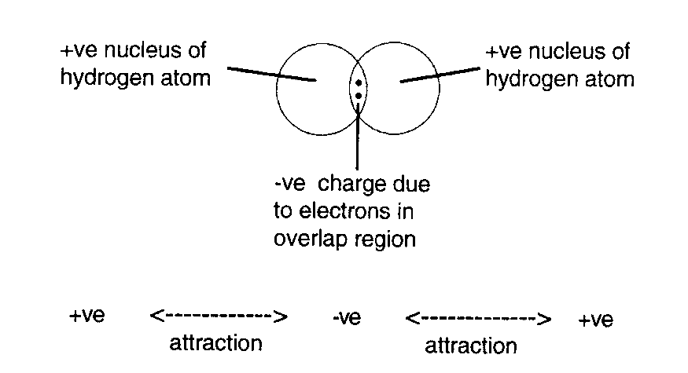

A covalent bond is the mutual attraction of two nuclei for a shared pair of electrons.
Since covalent bonds are a strong force of attraction, a lot of energy is required to overcome the forces of attraction and break a covalent bond.
As larger atoms have more energy levels, only the outer energy level is normally shown when energy levels are overlapped.
More than one bond can be formed between atoms leading to double and triple covalent bonds

Atoms | Diagram showing overlapped outer energy levels | Full Structural formula | Chemical formula |   Shape
Cl  Cl |  |  | Cl₂ | (Linear)
 | 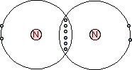 |  | N₂ | (Linear)
H  O |  | 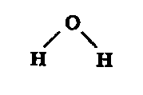 |  | (Bent)
 | 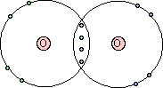 | O=O |  | (Linear)
Atoms | Diagram showing overlapped outer energy levels | Full Structural formula | Chemical formula | Shape
Cl  C |  |  |  | 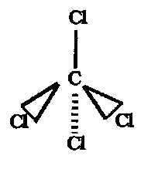  (tetrahedral)
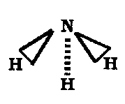
(pyramidal)
H
C

Covalent networks
Diamond, graphite, the element silicon, silicon carbide (SiC) and silicon dioxide (SiO₂) are examples of covalent substances with very high melting points. These substances don't exist as molecules. Instead they have giant network structures.
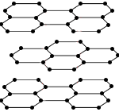
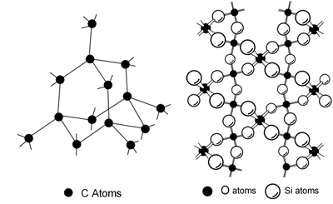
Covalent  network | Carbon diamond | Silicon dioxide SiO₂ | Carbon (graphite)
Use

Chemical Formulae
Chemical formulae tell you the number of atoms of each element in a molecule.
The formula for hydrogen chloride is HCl, water is H₂O and nitrogen hydride is NH₃.
The formula tells you the number of atoms of each element in a molecule of a covalent substance. e.g. water contains two atoms of hydrogen and one atom of oxygen.
A covalent network structure consists of a giant network of covalently bonded atoms, the formula of a covalent compound gives the simplest ratio of atoms of each element. e.g SiO₂ for every Si atom in the network there is two oxygen atoms.
In a similar way, because a large number of positive and negative ions are held together in an ionic compound, the formula of an ionic compound only indicates the ratio of ions present. e.g K₂S for every S²⁻ ion there are two K⁺ ions.
Diatomic molecules
A diatomic molecule contains two atoms joined together, e.g. hydrogen H₂, hydrogen chloride HCl.
Seven diatomic elements exist.
Hydrogen, nitrogen, oxygen, fluorine, chlorine, bromine and iodine are all diatomic elements their formulas are written as X₂ e.g. Oxygen is O₂
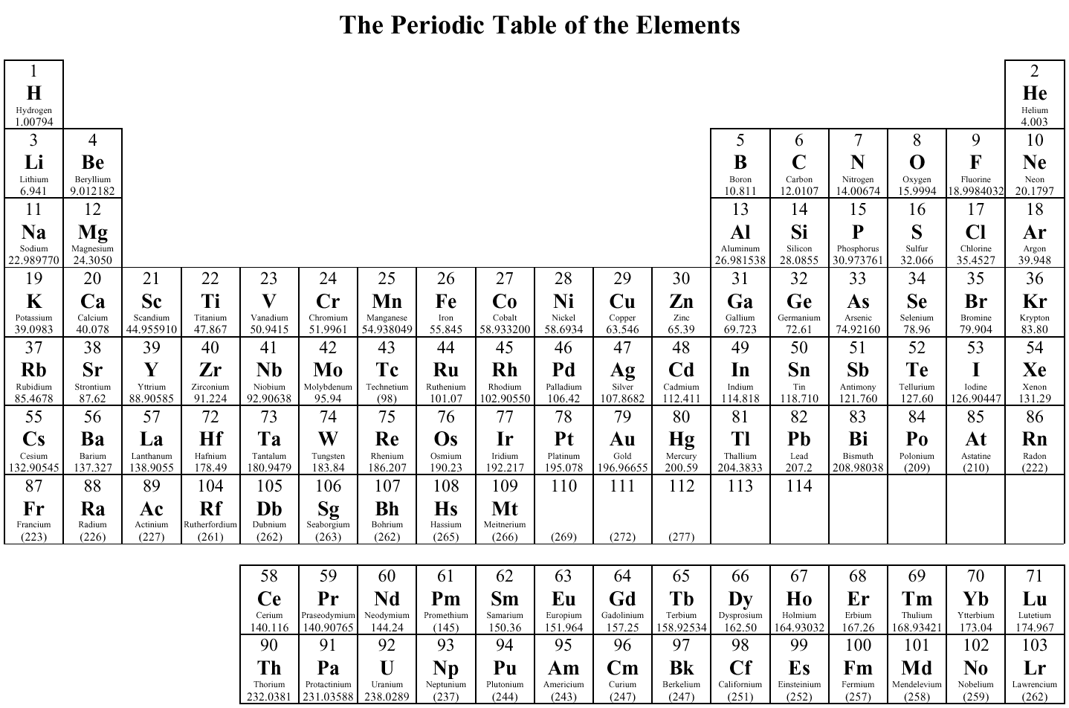
H₂ N₂ O₂ F₂ Cl₂ Br₂ I₂
Using valency numbers
Group number | 1 | 2 | 3 | 4 | 5 | 6 | 7 | 8
Valency | 1 | 2 | 3 | 4 | 3 | 2 | 1 | 0
To determine the formula of a substance we firstly determine its valency (the number of bonds an element will form). This is done from the position of the element in the periodic table.

To write the formula we
- Write name of compound.
- Write symbols of elements present.
- Write the valency no. under the appropriate element.
- Cancel the valency numbers if possible.
- Cross over the valency no.
- Write the formula.
Some simple examples are shown below.
Compound Hydrogen oxide
Symbols H O

Valency no. 1 2
Cross over nos
Formula H₂O
Compound Nitrogen hydride
Symbols N H

Valency no. 3 1
Cross over nos
Formula NH₃

Valency number of Transition elements
Transition elements can have more than one valency number. The valency number will be indicated by a Roman number in the name of the compound e.g. in copper (III) bromide, take the valency of copper to be 3. Then use the same method as shown by crossing over valency numbers. The valency of silver is always one.
Compound Silver iodide
Symbols Ag I

Valency no. 1 1
Cross over nos
Formula AgI
Compound Copper (III) bromide
Symbols Cu Br

Valency no. 3 1
Cross over nos
Formula CuBr₃

Formulae of compounds with complex/group ions
Often, ions exist that are not single charged atoms, but several atoms that are bonded together with an overall charge associated with them. These ions are called complex ions or group ions.

The formula for these ions can be found in the data booklet.
Two examples are the sulphate ion and the nitrate ion.
The charge associated with these group ions is the same as the valency when working out chemical formula.
 | formula | charge | valency
sulphate | SO₄²⁻ | Two negative | Two
nitrate | NO₃⁻ | One negative | One
Compound Calcium nitrate
Symbols Ca²⁺ NO₃⁻

Formula Ca²⁺(NO₃⁻)₂
Compound Sodium sulphate
Symbols Na⁺ SO₄²⁻

Formula (Na⁺)₂SO₄²⁻

Note: that you must put brackets around group ions if there is more than one group of them present in a chemical formula.
Formulae of compounds with prefixes
No valency numbers are used to write formulae with prefixes. Carbon monoxide and carbon dioxide each contain carbon joined to oxygen. The prefixes 'mon' (or mono) and 'di' are used to show how many atoms of oxygen are present. The table shows show what the prefixes mean:
Prefix | Mono or mon | Di | Tri | Tetra | Penta | Hexa
Meaning | 1 | 2 | 3 | 4 | 5 | 6
Carbon monoxide means carbon and one atom of oxygen CO
Carbon dioxide means carbon and two atoms of oxygen CO₂
Dinitrogen tetraoxide means two nitrogen and four oxygen N₂O₄
Formula mass
The formula mass of a substance can be calculated by totalling the relative atomic masses of all the atoms or ions in the formula. The units used for formula mass are atomic mass units (a.m.u.).
a) Ca | b) CuO
c) CO | d) H₂O
e) MgCl₂ | f) CuSO₄
g) CH₄ | h) C₂H₄

Calculations involving the mole (1)
One mole of any substance is defined as the gram formula mass.
To calculate the mass of one mole of the substance, simply express the formula mass in grams.
a)1 mole of Na | b) 1 mole of sodium chloride
c) 1 mole of carbon dioxide | d) 1 mole of water
e) 1 mole of copper carbonate | f) 1 mole of copper sulphate
g) 1 mole of sulphur dioxide | h) 1 mole of magnesium nitrate

Calculations involving the mole (2)
The number of moles can be calculated from a mass of substance and vice versa.

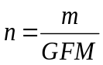

a) Calculate the mass of 2 moles of sodium | b) Calculate the mass of 0.5 moles of oxygen
c) Calculate the mass of 0.3 moles of CuCl₂ | d) Calculate the mass of 1.5 moles of Cu(NO)₃
e) Calculate the mass of 5 moles of sodium chloride | f) Calculate the number of moles in 63g of water
g) Calculate the number of moles in 222g of CaCl₂ | h) Calculate the number of moles in 10g of sodium hydroxide
Balancing equations
In a balanced chemical equation the number of atoms (or ions) on the reactant side is equal to the number of atoms (or ions) on the product side e.g.

2Ca + O₂ → 2CaO

Equations can only be balanced by putting an number in front of symbols and formulae e.g.

2Ca or 2CaO

Never change a formula to make it balance e.g. Ca₂O CaO₂ would be wrong as these are different compounds.

When balancing an equation with lots of elements it is useful to balance the elements in the order metal, non-metal, oxygen then hydrogen.

Example C₃H₈(g) + O₂(g) → CO₂(g) + H₂O(g)

Step 1 Balance the carbon atoms. There are 3 carbon atoms in the reactants, so there must be 3 in the products. There fore we need 3 CO₂ molecules on the right side.

C₃H₈ + O₂ → 3 CO₂ + H₂O

Step 2 Balance the hydrogen atoms. There are 8 hydrogen atoms in the reactants. Each moecule of water has 2 hydrogen atoms, so 4 molecules of water will give the required 8 H atoms.

C₃H₈ + O₂ → 3 CO₂ + 4 H₂O

Step 3 Balance the oxygen atoms. There are 10 oxygen atoms on the products side of the equation (3 x 2 = 6 from the CO₂ and 4 x 1 = 4 from the H₂O). Therefore we need 5O₂ molecules to supply the required 10 atoms.

C₃H₈ + 5 O₂ → 3 CO₂ + 4 H₂O

Step 4 Check that each atom is balanced. The reaction involves 3 carbon atoms, 8 hydrogen atoms and 10 oxygen atoms on each side.

i) N₂ (g) + H₂ (g) → NH₃ (g)
j) N₂O → N₂ (g) + O₂
- CaC₂ + H₂O → Ca(OH)₂ + C₂H₂
- CaCN₂ + H₂O → CaCO₃ + NH₃
- Fe + H₂O → Fe₂O₄ + H₂
- Na + O₂ → Na₂O
- Fe₂O₃ + CO → Fe + CO₂
- Mg + O₂ → MgO

- CH₄ + O₂ → CO₂ + H₂O
- H₂ + O₂ → H₂O
- AgNO₃ + Zn → Zn(NO₃)₂ + Ag
- C₅H₁₂ + O₂ → CO₂ + H₂O
- Fe + O₂ → FeO
- Al + O₂ → Al₂O₃
- Al + CuO → Cu + Al₂O₃
- SiO₂ (s) + C (s) → Si (s) + CO (g)

Reacting masses

Worked examples (this looks tricky, but it’s straight forward if you follow it carefully)

Example one

What mass of copper would be obtained by heating 4g of copper (II) oxide with an excess of carbon?
2CuO + C → 2Cu + CO₂

Example Two

What mass of hydrogen gas would be evolved if 6g of magnesium reacted completely with dilute sulphuric acid?
Mg + H₂SO₄ → MgSO₄ + H₂

Example Three

What mass of silver will be formed when 12.7g copper reacts with silver nitrate solution?
Cu + 2AgNO₃ → Cu(NO₃)₂ + 2Ag

Electrical Conductivity
Electricity is the flow of charged particles.
An electrical current can either be electrons or ions moving. Electrons flow through wires and ions flow through solutions.
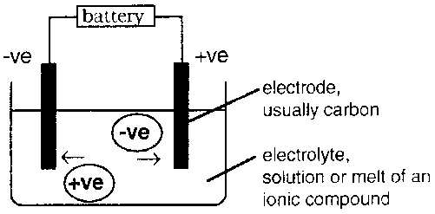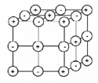
Ionic compounds do not conduct when solid but do conduct when molten or in solution.

When the ionic compound is melted or dissolved, the crystal lattice is broken so the ions can flow and compound conducts electricity.

Compound

Covalent compounds are made of neutral particles called molecules. Covalent compounds do not conduct electricity because they do not have charged particles which can flow.

Melting points and boiling points of compounds

Looking at the “state” of a substance (i.e. whether it is a solid, liquid or gas at room temperature) can give clue to the type of bonding.

To be sure of the bonding present in a substance the properties must be tested.

Substance | State |  |  | Type of bonding
Substance | Solid | Liquid | Gas | Covalent Molecular | Covalent Network | Ionic
sodium chloride
potassium chloride
copper (II) sulphate
magnesium oxide
calcium chloride
ethanol
silicon oxide
oxygen
Ionic compounds tend to have high melting points and boiling points.

This is because strong ionic bonds must be broken in order to break up the lattice structuree.
Lots of strong attractions between the ions

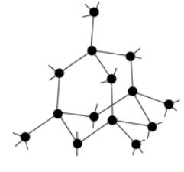
Covalent networks also have high melting and boiling points because strong covalent bonds have to be broken on melting.
Lots of strong covalent bonds inside the network

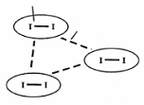
Covalent compounds made of molecules, have low melting and boiling points. As a result they can be found in any state at room temperature.
strong bonds inside
the molecule
weak bonds between
the molecule

Small covalent molecules have low melting and boiling points because only weak bonds exist between molecules which are easily broken on melting.
Solubility of compounds
Many ionic compounds are soluble in water. As they dissolve the lattice structure breaks up allowing water molecules to surround the separated ions.
Only a few covalent compounds will dissolve in water e.g. glucose, sucrose (sugars) and ethanol (an alcohol).
Most covalent compound will not dissolve in water. Grease, wax, tar, and oil paint are insoluble in water but will dissolve in other solvents such as petrol, paraffin or white spirit. These solvents are similar in structure to the compounds they are dissolving.
- Test the following ionic and covalent solids in water and white spirits, then complete the table below.

Solid | Ionic/Covalent | Soluble in water? | Soluble in white spirit?
paraffin wax

salol

copper sulphate

potassium permanganate

A Comparison of Properties
 | Covalent | Ionic
Type of element present?

What happens in bonding?

Type of structure?

Conducts as solid?

Conducts as liquid?

Conducts as solution?

Solubility in water?

State at room temperature?

c) Acid alkalis and bases
Level | Learning intentions | Traffic light
Nat 5 | I have investigated the effect of various soluble and insoluble oxides on the pH of water and can explain the pattern observed.
Nat 4 | I appreciate the large role non-metal oxides produced by the burning of fossil fuels play in the environment.
Nat 4 | I have researched the impact of acid rain and considered how it could be prevented.
Nat 4 | I appreciate the importance of CO₂ in the atmospheres and its role in the greenhouse effect and climate change.
Nat 4 | I have carried out practical experiments into neutralisation reactions and can relate this to the change in pH.
Nat 5 | I can state that acids contain H⁺ ions and alkalis contain OH⁻ ions.
Nat 5 | I can explain acids and alkalis in terms of the concentration of ions present and why water is neutral.
Nat 5 | I can explain the effect of dilution on the pH of a solution.
Nat 5 | I can state that alkalis are bases which dissolve in water.
Nat 4 | I can state the general equations and write word equations to describe the reactions of acids with bases and name the salts produced in these reactions.
Nat 5 | I can write balanced ionic equations for the reactions of acids and bases.
Nat 5 | I can identify the spectator ions present in a reaction and rewrite the equation omitting these ions.
Nat 5 | I can state a salt is a compound in which the hydrogen ions of an acid have been replaced wit metal ions (or ammonium ions).
Nat 5 | I can describe how to make an insoluble salt and identify the precipitate.
Nat 5 | I have carried out volumetric titrations to determine the accurate volumes involved in a chemical reaction such as neutralisation.
Nat 5 | I know concentration is expressed in moles per litre (mol l⁻¹).
Nat 5 | I can solve problem relating to moles, volume and concentration.
Nat 5 | I can calculate the concentration of acids/alkalis from the results of volumetric titrations.

Prior knowledge (from your previous studies you should know)

- pH - Substances can be divided in to three groups ...................., ............................ and ................ . The pH scale measures how acidic or alkaline a solution is.

................... pH<7

.................... pH=7

................... pH>7

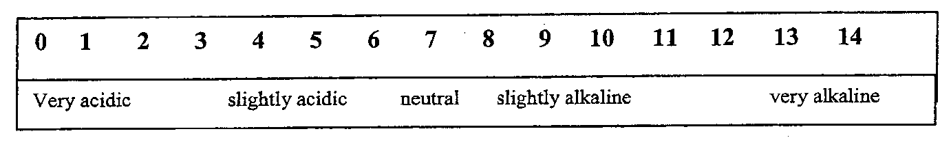
- .............................. ........................ or ......... .................. can be used to measure pH.

- Describe how you would test the pH of a solution

- Name some household acids

- Name some household alkalis

- What is a neutralisation reaction?
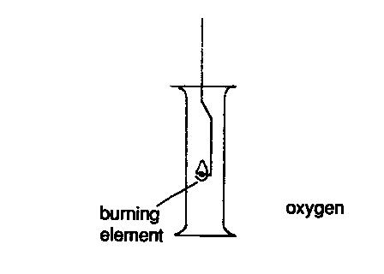
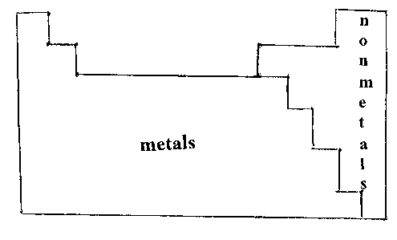
Acidic and basic oxides

Element | Name of oxide | Formula of oxide | Dissolves in water to give Acid/Alkali solution | Name of  acid/alkali | Formula of acid/alkali | Formula (showing charges)
S | sulphur dioixide | SO₂ |  | sulphurous acid | H₂SO₃
 | carbon dioxide
P |  | P₂O₅
Mg
 | calcium oxide
Na |  | Na₂O |  | sodium hydroxide
N | Nitrogen dioxide | N₂O |  | nitrous acid | HNO₂
Cu | Copper oxide | CuO

Non-metals
Non metals can react with …………………….. to produce compounds called oxides.

NON-METAL + OXYGEN → NON-METAL OXIDE

Non-metal oxides which dissolve in water produce ……………………… solutions.

Metals
Metals can react with …………………….. to produce compounds called oxides.

METAL + OXYGEN → METAL OXIDE

Metal oxides which dissolve in water produce ……………………… solutions.
Oxides of metals or non-metals which do not dissolve ........................ affect the pH

Non-metal oxides and Pollution
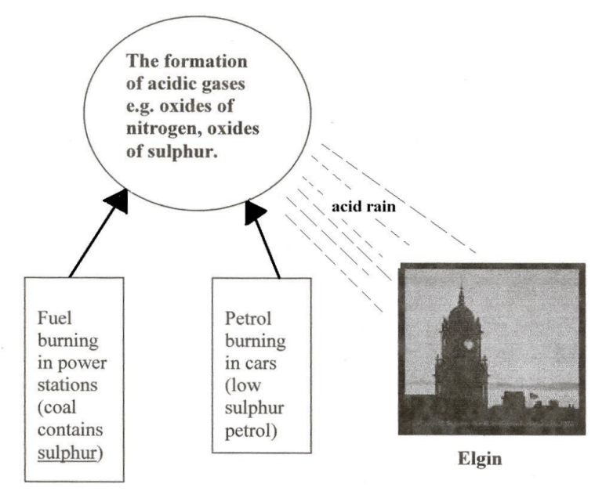
Carbon dioxide, ………………… ……………….. and ................... .............. dissolve in water to produce acids. Although these oxides are produced in nature the increased production of these oxides is leading to environmental problems including ................... rain and ................ global warming and ocean acidification.

- Research and list some possible effects of acid rain:-

- How can acid rain be prevented?

- Investigate/research sources of CO₂, in the atmosphere including the burning of fossil fuels and the cement manufacture.

Reactions of acids
Neutralisation removes hydrogen ions or hydroxide ions.
In neutralisation, the pH moves towards to 7.
When an acid is neutralised the number of H⁺ ions decreases.

- Give three examples of neutralisation in everyday life:-

…………………………………………………………………………………………………………

………………………………………………………………………………………………………....

…………………………………………………………………………………………………………

- Tick the flowing examples which show a neutralisation reaction, then colour the acids or alkaline solutions – red, blue as appropriate.

- Diluting a bottle of vinegar

- Taking indigestion tablets for heartburn

- Adding sugar to acidic lemonade

- Using baking soda to treat a bee sting

- Making a saturated solution of copper sulphate

- Adding salt to chips

- Adding limestone (calcium carbonate) to remove the acidic nature from lochs

- Iron nails rusting due to water

- Adding vinegar to a wasp sting

- Adding sugar to tea

- Evaporating water from salty water

- Rubbing a dockan leaf on an acidic nettle sting

Bonding In acids and alkalis
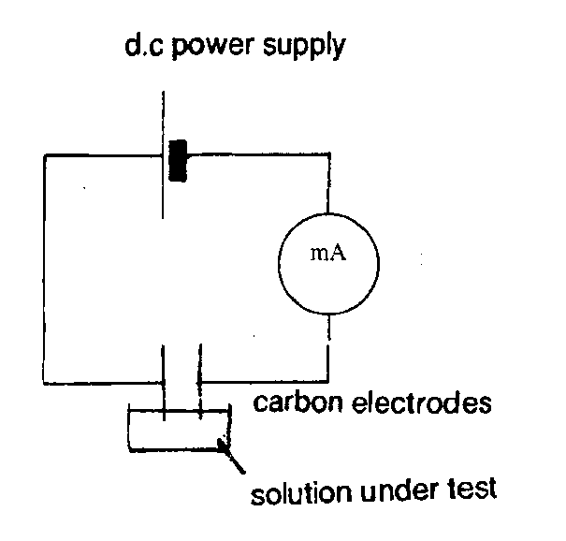

Formula | Conductivity
H₂O
HCl
HNO₃
KOH
NaOH

Covalent substances do not conduct electricity, and exist of neutral ………………..

Ionic substances conduct electricity when ……………. or………………. in water.

Since acids and ………………… conduct electricity, they must contain particles called …………………..

Water is a poor conductor of electricity, therefore there must be a very ………………. number of ions present. Water exists mainly of covalent molecules.

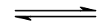 H₂O H⁺ + OH⁻

Electrolysis of an acid

Electricity can be used to breakdown an acid. “ Electro “ means electricity and “ lysis “ means to breakdown.

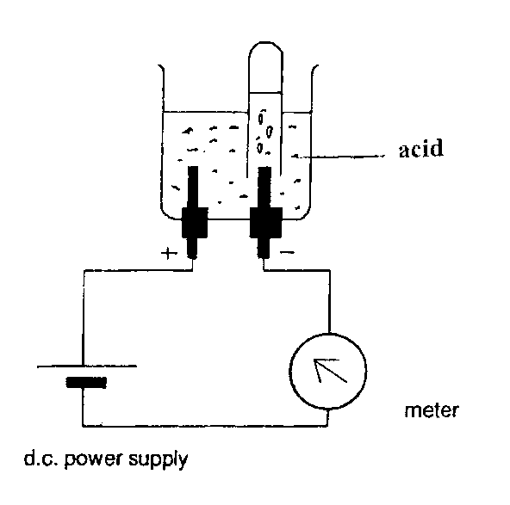

1. Identify the gas produced at the negative electrode?

……………………………………………………

2. Identify the ion which is present in all acids?

…………………………………………………….

Acidic – alkali –neutral

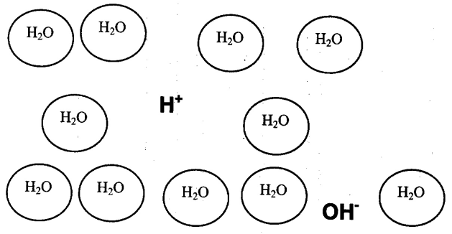 |  | Water consists of water molecules with a tiny number of ions, the greater the number of ions, the greater the electrical conductivity. Water conducts electricity only to a small extent due to having a small number of ions present.
Water is neutral
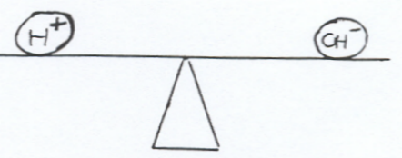

Number of H⁺_{(aq)} = Number of OH⁻ _{(aq)}
Acidic solutions
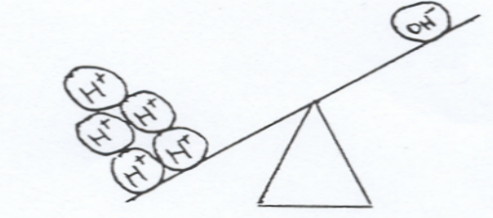
Number of H⁺_{(aq)} > Number of OH⁻_{(aq)}

Alkaline solutions
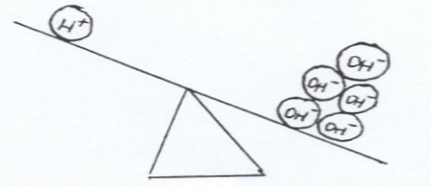
Number of OH⁻_{(aq)} > Number of H⁺_{(aq)}

Dilution of an acid reduces the H⁺_{(aq)} ion concentration leading to a decrease in acidity. One 10 fold dilution reduces the H⁺_{(aq)} ion concentration to one tenth of the original value, so leading to a rise in one pH unit for an acid.
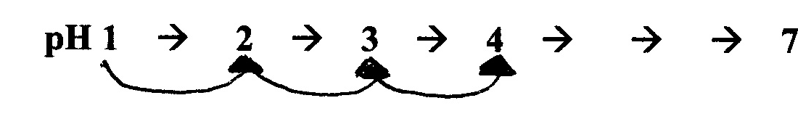
 | ten-fold dilution |  | ten-fold dilution |  | ten-fold dilution | The dilution of an alkali lowers the pH towards 7, while the dilution of an acid raises the pH towards 7.

Neutralisation of an acid with an alkali

 |  |  |  | 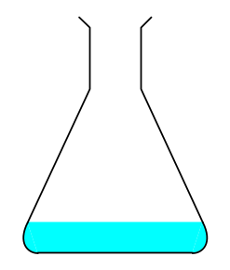 |  | Add universal indicator  (3 to 5 drops) |  |  | 20cm³ HCl acid +  universal indicator
 |  |  |  |  |  | Hydrochloric  Acid (20cm³) |  |  | 20cm³ HCl acid +  universal indicator
 |  |  | heat solution to evaporate the water |  |  |  | Activated charcoal (removes indicator) | 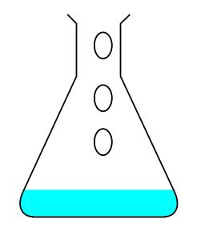 | Sodium hydroxide  solution added until neutral solution results
filtration
Hydrochloric acid(aq) + Sodium hydroxide (aq) → Sodium Chloride (aq) + water (l)

Naming salts

Hydrochloric acid gives salts that end in chloride
Nitric acid gives salts that end in nitrate
Sulphuric acid gives salts that end in sulphate

The start of the name of the salt comes from the alkali e.g sodium hydroxide would give salts starting with sodium.

ACID + ALKALI SALT + WATER

+ sodium sodium + water
hydroxide nitrate

hydrochloric + potassium + water
acid hydroxide

sulphuric + calcium + water
acid sulphate

Spectator ions

Spectator ions are ions which are present at the start and end of a chemical reaction, and are unchanged. Spectator ions play no part in the reaction.

ACID + ALKALI SALT + WATER

+ potassium hydroxide potassium nitrate + water

H⁺NO₃⁻(aq) + + H₂0(l)

Is water ionic or covalent?

Are acids ionic or covalent?

Which ion is common to all acids?

Are alkalis ionic or covalent?

Which ion is common to all alkalis?

Rewrite the chemical equation, but this time separating all the ions.
Remember covalent compounds contain molecules, not ions.

Name the two spectator ions?

Rewrite the equation without the spectator ions?

If you work through the same steps for the neutralisation of any acid by any alkali, the actual reaction is always the same. That is:-

H⁺ ions from the …………….. join with ……………. ions from the alkali to form covalent ……………… molecules.

Neutralisation of an acid with a basic oxide

The opposite of an acid is called a base.
Bases are metal oxides and metal hydroxides.
A soluble metal oxide/hydroxide is an alkali

Sulphuric acid  (2cm depth) | 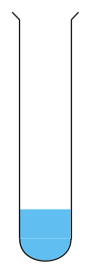 | warm acid safely |  | One spatula full of  copper oxide (basic  oxide)

ACID + BASIC OXIDE SALT + WATER

sulphuric + copper oxide +
acid

H₂SO₄ (aq) + ZnO (s) ZnSO₄(aq) +

H⁺Cl⁻(aq) + (Al³⁺)₂(O²⁻)₃ (s) +

H⁺NO₃⁻ (aq) + Mg²⁺O²⁻ (s) +

(H⁺)₂SO₄²⁻ (aq) + Ca²⁺O²⁻ (s) +

Rewrite the following equation showing the charges on the ions.

2HNO₃(aq) + CuO(s) Cu(NO₃)₂ + H₂O(l)

Name the spectator ion …………….
Rewrite the equation without the spectator ions.

Neutralisation of acids with metal carbonates

Formula of  acid | Name of carbonate | Formula of carbonate | Effervescence? | Effect of gas on  limewater | Gas
HCl | calcium carbonate | CaCO₃
H₂SO₄ | copper carbonate
HCl | sodium carbonate | Na₂CO₃
H₂SO₄ | zinc carbonate

Metal carbonates when added to acids, produce …………… ……………. gas.

ACID + METAL SALT + WATER +
CARBONATE

hydrochloric + calcium + +
acid carbonate

H⁺NO₃⁻ + Zn²⁺CO₃²⁻(s) + +

+ Mg²⁺SO₄²⁻(aq) + +

H⁺NO₃⁻ (aq) + Mg²⁺CO₃²⁻ (s) + +

H⁺Cl⁻(aq) + Zn²⁺CO₃²⁻ (s) + +

(H⁺)₂SO₄²⁻ (aq) + Ca²⁺CO₃²⁻ (s) + +

Rewrite the following equation showing the charges on the ions.

2HCl(aq) + NiCO₃(s) NiCl₂(aq) + H₂O(l)

Name the spectator ion …………….
Rewrite the equation without the spectator ions.

Neutralisation of acids with a reactive metal

Metal | Observation
zinc
magnesium
iron
copper
calcium

Acids react with reactive metals to produce ……………………….. gas.

ACID + REACTIVE METAL SALT + ………………
(above ………… in reactivity series)

H⁺NO₃⁻(aq) + Zn(s) +
acid

+ Ca (s) Ca²⁺(Cl⁻)₂(aq) +

H⁺NO₃⁻ (aq) + Mg (s) +

H⁺Cl⁻(aq) + Zn (s) +

(H⁺)₂SO₄²⁻ (aq) + Ca (s) +

Rewrite the following equation showing the charges on the ions.

2HCl(aq) + Li(s) 2LiCl (aq) + H₂(g)

Name the spectator ion …………….
Rewrite the equation without the spectator ions.

Naming salts

A salt is made when the H⁺ ions of an acid are replaced by an NH₄⁺ ion or a metal ion.

- ACID + SALT +

- + BASIC OXIDE + WATER

- ACID + METAL + +
CARBONATE

- + METAL +
(above H in the
reactivity series)

The name of the salt will depend on the parent acid used in the neutralisation reaction. The acid contributes the second part of the name of the salt:-

Parent acid | Salt ending due to acid | Acid Formula
 | chloride | HCl
nitric acid |  | HNO₃
sulphuric acid | sulphate

Name the products produced in the following reactions.

a. hydrochloric acid neutralising calcium hydroxide? …………………………………

b. sodium hydroxide neutralising sulphuric acid? …………………………………

c. lithium reacting with nitric acid? …………………………………

d. nitric acid neutralising magnesium oxide? …………………………………

e. potassium carbonate neutralising hydrochloric acid? …………………………………

f. magnesium oxide neutralising hydrochloric acid? …………………………………

Write down the names of the parent acid and alkali in the example below:-

g. + lithium sulphate + water
h. + aluminium nitrate + water

Soluble salts

To determine whether a salt is soluble or insoluble, check the table of solubilities in your data booklet. Circle the salts below which are soluble salts:-

sodium chloride lead carbonate calcium nitrate

potassium nitrate iron sulphate magnesium sulphate

Soluble salts can be made from the reactions of acids by neutralisation.

ACID + METAL SALT + WATER + CARBON
CARBONATE DIOXIDE

+ BASIC SALT + WATER
OXIDE

ACID + METAL SALT + HYDROGEN
(REACTIVE)

More and more metal carbonate or basic oxide should be added, until all the acid is used up i.e. excess solid has been added (more than required to complete the reaction).

The technique used to remove the excess solid from the solution is called ……………………..

Evaporation is used to remove the ……………....... from the solution, to leave crystals of the soluble salt.
Insoluble Salts
Mixing two ionic solutions can produce an insoluble solid called a ……………………..

Using your data booklet, circle the salts below which are insoluble:-

lithium chloride iron carbonate silver chloride

calcium carbonate barium sulphate magnesium nitrate

When two ionic solutions of soluble salts are mixed, the ions can exchange positions. One of the two salts could precipitate out as an insoluble solid, while the other soluble salt will remain dissolved in solution.

silver nitrate (aq) + potassium bromide (aq) → silver bromide (s) + potassium nitrate (aq)

This is called a precipitation reaction. The insoluble salt can be removed by the technique of ………………………

Solution A | Solution B | What happened on  mixing? | Name of solid  (precipitate)
barium nitrate | sodium sulphate | white precipitate | barium  sulphate
sodium sulphite | barium nitrate
copper nitrate | sodium carbonate
lead nitrate | sodium iodide
sodium chloride | silver nitrate
copper chloride | ammonium carbonate

Standard solutions

A solution is formed when a solute is dissolved in a solvent.
A standard solution is a solution of known concentration.

Concentration is measured in mol l⁻¹.

n = CV

1. Calculate the number of moles of sodium chloride in 250cm³ of 0.5 mol l⁻¹ solution?

2. What is the mass of sodium chloride needed to make this solution?

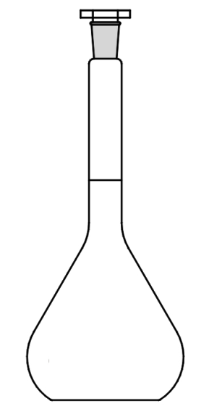
3. To make 250 cm³ of a standard solution with a concentration of, 0.5moll⁻¹ you need to:
- Accurately measure the calculated mass of the solute into a beaker.
- Add 100 cm³ of distilled water and stir the mixture using a glass rod until the solid has completely dissolved.
- Use a funnel to transfer the contents of the beaker into a 250 cm³ volumetric flask.
- Rinse the beaker and glass rod thoroughly with distilled water and pour the rinsings into the volumetric flask.
- Carefully add distilled water to the volumetric flask until the bottom of the meniscus is level with the horizontal line on the neck of the flask.
- Holding the stopper into the neck of the flask, carefully turn the flask upside down several times to thoroughly mix the solution.

4. Calculate the number of moles of lithium fluoride in 250cm³ of 2.0 mol l⁻¹ solution and the
mass of lithium fluoride needed to make this solution?
Titration
Titration can be used to find an average volume of an acid or an alkali, required in a neutralisation reaction.

A chemical indicator is used, leading to a colour change, when the neutralisation is complete.

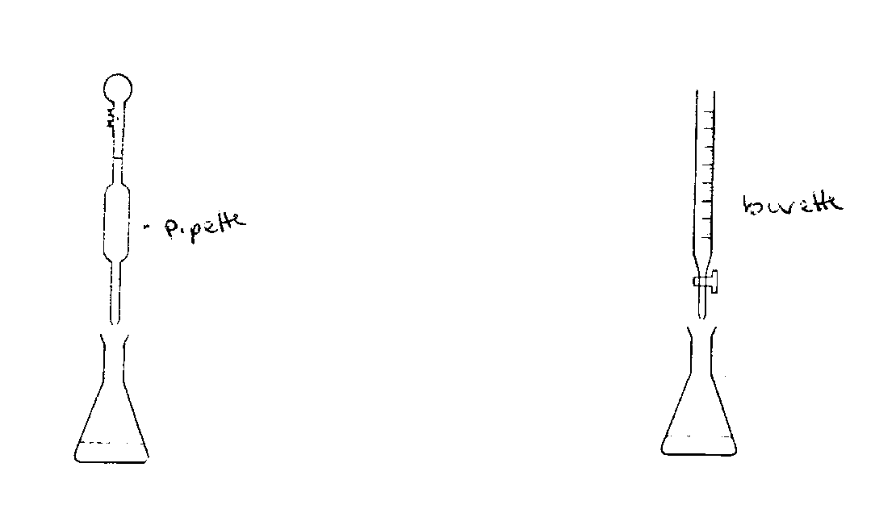

Burette
Pipette

25cm³ of sodium hydroxide solution Vinegar (ethanoic acid) should be
of concentration 0.1 moll⁻¹ should added gradually from the burette
be pipetted into a conical flask, then until the indicator changes colour methyl orange indicator added to the
conical flask

Final burette reading (cm³)
Initial burette reading (cm³)
Volume of acid used (cm³)

Average volume (cm³) =

Volumetric titrations

Worked examples (this looks tricky, but it’s straight forward if you follow it carefully)

Example one
25 cm³ of hydrochloric acid, concentration 1 mol l⁻¹, required 50cm³ of sodium hydroxide solution for complete neutralisation. Calculate the concentration of the sodium hydroxide solution.

Example two
Calculate the volume of sulphuric acid, concentration 2 mol l⁻¹, required to neutralise 25 cm³ of sodium hydroxide solution concentration 1 mol l⁻¹.

Example three
12.8 cm³ of potassium hydroxide solution is neutralised by 25.0 cm³ of nitric acid, concentration 0.22 mol l⁻¹. Calculate the concentration of the potassium hydroxide solution.

